UNIVERSITY OF ENERGY AND NATURAL RESOURCES, SUNYANI.
SCHOOL OF SCIENCES.
DEPARTMENT OF INFORMATION TECHNOLOGY AND DECISION SCIENCES.
AUTOMATED DETECTION AND CLASSIFICATION OF PHOTOVOLTAIC PANEL DEFECTS USING YOLOV8 WITH TFLITE MOBILE INTEGRATION.
BY:
MONICA GYAMFUAH UEB3258522
ABUBAKARI RAFIATU UEB3252922
OWUSU EMMANUEL UEB3263222
AGYEKUM ISAAC UEB3251322
ASARE SOLOMON WILLIAM UEB3259122.
SUPERVISED BY: DR. SAMUEL O. FRIMPONG
A PROJECT SUBMITTED TO THE DEPARTMENT OF INFORMATION TECHNOLOGY AND DECISION SCIENCES, IN PARTIAL FULFILLMENT OF THE REQUIREMENTS FOR THE AWARD OF THE DEGREE OF BACHELOR OF SCIENCE IN INFORMATION TECHNOLOGY.
SUNYANI, GHANA.
SEPTEMBER, 2026.

DECLARATION
Student's Declaration.
We, Monica Gyamfuah, Abubakari Rafiatu, Owusu Emmanuel, Agyekum Isaac and Asare Solomon William declare that this project report titled "Automated Detection and Classification of Photovoltaic panel defects using YoloV8 with TFLite Mobile Integration" is the result of our own original investigation and development. It has not been presented in part or whole for any degree, diploma, or certificate in this or any other tertiary institution. All sources consulted, scholarly references, software libraries, and data repositories have been duly acknowledged with full citations in accordance with the academic regulations of the University of Energy and Natural Resources (UENR).

MONICA GYAMFUAH ………………………… ………………………….
(UEB3258522) Signature Date.

ABUBAKARI RAFIATU ………………………… ………………………….
(UEB3252922) Signature Date.

OWUSU EMMANUEL .......................... ……...................
(UEB3263222) Signature Date.
AGYEKUM ISAAC ........................... ……...................
(UEB3251322) Signature Date.

ASARE SOLOMON WILLIAM ........................... ……...................
(UEB3259122) Signature Date.

CERTIFIED BY:
Dr. Samuel O. Frimpong ........................... ……...................
(Supervisor) Signature Date.

Dr. Anokye Acheampong Amponsah ........................... ……...................
(Head of Department) Signature Date.

DEDICATION
We dedicate this project report first and foremost to the Almighty God, whose grace, wisdom, and sustaining strength carried us through the intensive cycles of software engineering, neural network training, and field evaluations.
We also dedicate this work to our beloved parents and families, whose continuous prayers, sacrifices, emotional encouragement, and financial commitments made our university education possible. Their belief in our capacity to solve real-world problems kept us motivated during the most demanding technical sprints.
Finally, this work is dedicated to the frontline solar technicians and maintenance engineers working across the Bui Power Authority solar plant and northern Ghanaian mini-grids. Your tireless dedication under harsh tropical weather ensures that clean electrical power reaches homes, hospitals, and schools. We built SolarScan AI to make your daily field operations safer, faster, and more precise.

ACKNOWLEDGEMENT
We express our profound and sincere gratitude to our supervisor, Dr. Samuel O. Frimpong, of the Department of Information Technology and Decision Sciences (ITDS), University of Energy and Natural Resources (UENR), Sunyani. His constructive guidance, meticulous technical reviews, and insistence on academic rigor kept our research focused on solving authentic industrial challenges in Ghanaian solar utility management.
We also express our appreciation to Mr. Joshua A. Weyori for his technical counsel during the early system architectural formulation and computer vision pipeline design. Our heartfelt thanks extend to the entire academic and laboratory staff of the School of Sciences for providing a conducive environment for research and practical software prototyping.
Special acknowledgement goes to the operations and field engineering personnel at the Bui Power Authority (BPA) 50MW Solar Plant in the Banda District of the Bono Region. Their practical insights regarding the realities of Harmattan dust deposition, reverse-bias thermal hotspots, inverter curtailment, and the recurring difficulties of validating international manufacturer warranty claims provided the empirical foundation for our system requirements.
Lastly, we thank our fellow classmates and the domain evaluators who participated in our user acceptance testing and System Usability Scale evaluations, providing the candid feedback that shaped the final user interface design.

ABSTRACT
Photovoltaic energy infrastructure is expanding rapidly across Ghana to meet national clean generation targets, anchored by utility assets such as the Bui Power Authority 50MW solar plant in the Bono Region. However, field operations in Sub-Saharan Africa confront severe environmental stressors, including Harmattan wind-borne dust crusting, ambient temperatures exceeding 38°C, and road transit vibrations that accelerate module degradation. Conventional maintenance relies on manual walk-through inspections that are physically hazardous and unscalable. Furthermore, commercial cloud-based AI inspection platforms fail completely in rural installations due to telecommunication dead zones, while over 80% of local warranty claims are rejected by manufacturers due to a lack of calibrated, timestamped thermal evidence satisfying IEC 62446-3 standards.
Grounded in Design Science Research and the DeLone and McLean Information Systems Success Model, this study presents SolarScan AI, an edge-first, multi-platform computer vision system that automates photovoltaic defect triage across field operations. Developed under an adapted Spiral Model using a curated 1,820-image multimodal dataset across nine defect classes, the platform integrates an INT8-quantized YOLOv8-Nano detector, an OpenCV multi-spectral filter bank, a double-layer validation gatekeeper, a calibrated NOCT thermodynamic power derating engine, and PURC tariff financial calculators. Inspection records generate standardized IEC 62446-3 work orders protected by HMAC-SHA-256 cryptographic audit chaining. The platform is engineered across three deployment targets: a local edge server running on PC hardware, a standalone native Android application package for field mobility, and a cloud web platform hosted on Vercel for Apple iOS users. Empirical evaluation on an independent test partition demonstrated 92.7% mAP@50, 91.8% precision, and 89.4% recall across all nine defect classes within 127 milliseconds edge CPU latency, a 94.3% reduction in non-solar false alarms, verification of all 22 functional requirements, and an exceptional System Usability Scale score of 84.3 out of 100 across twelve domain evaluators. The study proves that quantized edge intelligence delivers an autonomous, economically practical paradigm for solar utility asset stewardship in connectivity-constrained African installations.

TABLE OF CONTENTS

DECLARATION 2
DEDICATION 5
ACKNOWLEDGEMENT 6
ABSTRACT 7
TABLE OF CONTENTS 8
LIST OF ABBREVIATIONS 15
CHAPTER ONE: INTRODUCTION 18
1.1 Background of the Study 18
1.2 Context of Photovoltaic Operations in Ghana 19
1.3 Statement of the Problem 19
1.4 Research Questions 20
1.5 Aim and Objectives of the Study 21
1.5.1 Aim 21
1.5.2 Specific Objectives 21
1.6 Significance of the Study 22
1.7 Scope and Delimitations of the Study 22
1.8 Organization of the Study 23
CHAPTER TWO: LITERATURE REVIEW 24
2.1 Introduction 24
2.2 Photovoltaic Infrastructure and Maintenance Realities in Ghana 24
2.3 Taxonomy of Photovoltaic Panel Defect Classes 25
2.3.1 Thermal Hotspot Defects 25
2.3.2 Silicon Wafer Micro-Crack Defects 26
2.3.3 Harmattan Dust and Particulate Soiling 26
2.3.4 Polymer Encapsulant Delamination 27
2.3.5 Electrochemical Discoloration and EVA Browning 28
2.3.6 Pristine Healthy Photovoltaic Module Baseline 29
2.4 Theoretical Framework 31
2.4.1 Design Science Research (DSR) Paradigm 31
2.4.2 DeLone and McLean Information Systems Success Model 32
2.5 Evolution of Photovoltaic Inspection Modalities 33
2.6 Edge Computing, Model Compression, and Post-Training Quantization (INT8) 34
2.7 Multi-Spectral Vision and Calibrated Thermodynamic Severity Formulations 34
2.8 Review of Existing Photovoltaic Inspection Systems 35
2.9 Comparative Analysis and Rationale for the Proposed System 36
2.10 Research Gap Identification 37
CHAPTER THREE: METHODOLOGY AND SYSTEM DESIGN 39
3.1 Introduction 39
3.2 Research Design 39
3.3 System Methodology: Adapted Spiral Engineering Lifecycle 40
3.4 Data Collection, Provenance, and Dataset Composition 41
3.5 System Requirements Specification 42
3.5.1 Functional Requirements 42
3.5.2 Non-Functional Requirements 46
3.6 System Architecture: Edge-First Three-Tier Architecture 47
3.6.1 Presentation and View Layer 48
3.6.2 Business Logic and Inference Layer 48
3.6.3 Data Storage and Persistence Layer 48
3.6.4 Security Hardening and Middleware 49
3.7 Multi-Step Technician Authentication and RBAC Workflow 49
3.8 Multi-Platform Deployment and Field Synchronization Architecture 49
3.9 Technology Stack Summary 50
3.10 System Testing Strategy 52
3.11 System Design Diagrams 53
3.11.1 UML Use Case Diagram 53
3.11.2 Entity Relationship Diagram (ERD) 54
3.11.3 System Execution Flowchart 55
3.11.4 Relational Database Schema Design 56
3.12 Chapter Summary 57
4.1 Introduction 58
4.2 System Implementation Overview 58
4.3 Module-by-Module Implementation 58
4.3.1 Scan Lab: Hardware Canvas Shutter Viewport 58
4.3.2 Enterprise Authentication and 5-Tier RBAC Console 59
4.3.3 Real-Time 5-Point Password Criteria Validation 60
4.3.4 Two-Step Offline Password Recovery Subsystem 60
4.3.5 Active Technician Profile Workspace in Tactile Sidebar 61
4.3.6 Direct In-Session Password Management Interface 61
4.3.7 Thermal Hotspot Multi-Spectral Diagnostic Detection 62
4.3.8 Silicon Wafer Micro-Crack Bounding Box Analysis 63
4.3.9 Harmattan Dust Soiling Chromaticity Absorption Analysis 64
4.3.10 Pristine Photovoltaic Module Baseline Verification 65
4.3.11 Gatekeeper Layer 2 Rejection: Savanna Vegetation Triage 66
4.3.12 Gatekeeper Layer 1 Rejection: Non-Solar Indoor Surfaces 66
4.3.13 Gatekeeper Acceptance: Authentic Photovoltaic Module Cleared 67
4.3.14 Autonomous Drone GIS Inspection Module and 24-Array Grid 67
4.3.15 Evidence Hub and Tamper-Evident SHA-256 Audit Trail 68
4.3.16 Executive Plant Health Analytics and Telemetry Dashboard 68
4.3.17 Cross-Platform Deployment Architecture: Standalone Android Application and Universal iOS Web Interface 69
4.3.18 Database Manager and Offline Client-to-Edge Synchronisation 70
4.4 System Testing Results 70
4.4.1 Per-Class Diagnostic Performance on Independent Test Partition 70
4.4.2 Functional Requirements Verification Matrix 72
4.4.3 Evaluation Against the DeLone and McLean IS Success Model 75
4.4.4 System Usability Scale (SUS) Empirical Evaluation 76
CHAPTER FIVE: SUMMARY, CONCLUSIONS, AND RECOMMENDATIONS 78
5.1 Summary of the Study 78
5.2 Conclusions Directly Addressing Research Questions 78
5.3 Recommendations for Future Development 79
REFERENCES 81
APPENDIX A: SELECTED SYSTEM SOURCE CODE LISTINGS 85
APPENDIX B: PROJECT REPOSITORY AND SYSTEM DEPLOYMENT GUIDE 87

LIST OF TABLES
Table 2.0.1 Comprehensive Taxonomy of Photovoltaic Defect Classes Detected by SolarScan AI 30.
Table 2.0.2 DeLone and McLean Information Systems Success Model Dimensions Applied to SolarScan AI 32.
Table 2.0.3 Comparative Matrix of Existing Photovoltaic Diagnostic Systems and SolarScan AI 36.
Table 3.0.1 Functional Requirements of the SolarScan AI Platform (FR-01 to FR-22) 42.
Table 3.0.2 Non-Functional Requirements of the SolarScan AI Platform 46.
Table 3.0.3 Technology Stack Summary and Engineering Design Rationale 50.
Table 4.4 System Usability Scale (SUS) Empirical Evaluation Scores Across 12 Domain Evaluators 76.

Figure 1. Thermal Hotspot in a Photovoltaic Cell Detected by Infrared Imaging 26.
Figure 2.2 Silicon Wafer Micro-Crack Pattern Captured via Electroluminescence Imaging 27.
Figure 2.3 Harmattan Dust and Particulate Soiling Accumulation on Module Glass 28.
Figure 2.4 Internal Polymer Encapsulant Delamination Separating EVA Layers 29.
Figure 2.5 Electrochemical Discoloration and Photochemical EVA Browning on Cell Surfaces 30.
Figure 2.6 Pristine Healthy Photovoltaic Module Baseline Reference Image 31.

Figure 3.1 Adapted Spiral Engineering Design Lifecycle for SolarScan AI 41.
47.
Figure 3.2 Edge-First Three-Tier Architecture of the SolarScan AI Platform 48.
Figure 3.3 UML Use Case Diagram for the SolarScan AI Platform 55.
Figure 3.4 Entity Relationship Diagram (ERD) for the SolarScan AI Relational Engine 56.
Figure 3.5 Comprehensive System Flowchart Tracing SolarScan AI Execution Path 57.
Figure 3.6 Relational Database Schema and Constraint Architecture for SolarScan AI 58.
Figure 4.1 SolarScan AI Scan Lab, Clean Hardware Canvas Shutter Viewport 60.
Figure 4.2 Enterprise Authentication Console with Sign-In, Register, and Reset Password Tabs 60.
Figure 4.3 Real-Time 5-Point Password Criteria Checklist (PasswordCriteriaBox) 61.
Figure 4.4 Two-Step Registered Email Password Recovery Subsystem in Offline Field Mode 61.
Figure 4.5 Logged-In Technician Profile in the Tactile Hardware Navigation Sidebar 62.
Figure 4.6 Direct Password Management Triggered from Active Profile Card 63.
Figure 4.7 Multi-Spectral Diagnostics, Thermal Hotspot Detection with Full HUD Overlay 63.
Figure 4.8 Multi-Spectral Diagnostics, Silicon Wafer Micro-Crack Bounding Box Analysis 64.
Figure 4.9 Multi-Spectral Diagnostics, Harmattan Dust Soiling Chromaticity Analysis 65.
Figure 4.10 Pristine Photovoltaic Module Baseline Verification (100% Health Score) 66.
Figure 4.11 Double-Layer Gatekeeper, Rejection of Savanna Grass Peripheral Capture 67.
Figure 4.12 Double-Layer Gatekeeper, Rejection of Non-Solar Indoor Surface Upload 67.
Figure 4.13 Gatekeeper Acceptance, Authentic Photovoltaic Module Successfully Cleared 68.
Figure 4.14 Autonomous Drone GIS Inspection Module, 24-Array Interactive Flight Grid 68.
Figure 4.15 Evidence Hub, Tamper-Evident SHA-256 Cryptographic Audit Trail for Warranty 69.
Figure 4.16 Executive Photovoltaic Plant Health Analytics Dashboard (Level 4 Asset Manager View) 69.
Figure 4.17 Cross-Platform Deployment Architecture: Standalone Android Mobile Application and Universal Apple iOS Web Interface 70.
Figure 4.18 Database Manager, Offline Client-to-Edge Synchronisation and Telemetry 71 76.

LIST OF ABBREVIATIONS
AI : Artificial Intelligence.
API : Application Programming Interface.
AP@50 : Average Precision at Intersection over Union Threshold of 0.50.
BPA : Bui Power Authority.
COCO : Common Objects in Context (Image Benchmark Dataset)
CPU : Central Processing Unit.
CSRF : Cross-Site Request Forgery.
CSV : Comma-Separated Values.
CV : Computer Vision.
D&M : DeLone and McLean Information Systems Success Model.
DSR : Design Science Research.
EL : Electroluminescence.
ERD : Entity Relationship Diagram.
EVA : Ethylene-Vinyl Acetate (Photovoltaic Encapsulant Polymer)
FLIR : Forward-Looking Infrared.
FR : Functional Requirement.
GHS : Ghana Cedi (Official Currency of Ghana)
GIS : Geographic Information System.
GPS : Global Positioning System.
GRIDCo : Ghana Grid Company Limited.
HCI : Human-Computer Interaction.
HMAC : Hash-Based Message Authentication Code.
HSV : Hue-Saturation-Value (Colour Representation Space)
HTTP : Hypertext Transfer Protocol.
ICT : Information and Communication Technology.
IDE : Integrated Development Environment.
IEC : International Electrotechnical Commission.
IEEE : Institute of Electrical and Electronics Engineers.
INT8 : Eight-Bit Integer Quantization Precision.
IR : Infrared.
IRT : Infrared Thermography.
JSON : JavaScript Object Notation.
JWT : JSON Web Token.
mAP : Mean Average Precision.
MNO : Mobile Network Operator.
NFR : Non-Functional Requirement.
NOCT : Nominal Operating Cell Temperature.
NPU : Neural Processing Unit.
O&M : Operations and Maintenance.
ONNX : Open Neural Network Exchange.
ORM : Object-Relational Mapping.
OTP : One-Time Password.
OWASP : Open Worldwide Application Security Project.
PDF : Portable Document Format.
PID : Potential Induced Degradation.
PNG : Portable Network Graphics.
PURC : Public Utilities Regulatory Commission (Ghana)
PV : Photovoltaic.
PWA : Progressive Web Application.
QA : Quality Assurance.
QR : Quick Response (Two-Dimensional Matrix Barcode)
RBAC : Role-Based Access Control.
REST : Representational State Transfer.
RGB : Red-Green-Blue (Colour Model)
RQ : Research Question.
SDLC : Systems Development Life Cycle.
SHA : Secure Hash Algorithm.
SLA : Service Level Agreement.
SQL : Structured Query Language.
SUS : System Usability Scale.
TPU : Tensor Processing Unit.
UAT : User Acceptance Testing.
UEB : Undergraduate Enrollment Identification Code (UENR)
UENR : University of Energy and Natural Resources, Sunyani.
UI : User Interface.
UML : Unified Modeling Language.
URL : Uniform Resource Locator.
USD : United States Dollar.
UX : User Experience.
WAL : Write-Ahead Logging.
WIL : Work-Integrated Learning.
YOLO : You Only Look Once (Real-Time Object Detection Architecture)

CHAPTER ONE: INTRODUCTION

1.1 Background of the Study
The global transition toward sustainable energy sources has accelerated over the past two decades, propelled by the compounding pressures of fossil fuel depletion, climate change mitigation targets, and the imperative for distributed electrical generation across developing nations. Photovoltaic (PV) technology has emerged as one of the most viable clean energy solutions globally, supported by steep manufacturing cost reductions and continuous improvements in crystalline silicon semiconductor conversion efficiency (International Renewable Energy Agency [IRENA], 2023). Within the Sub-Saharan African sub-region, the West African corridor receives abundant solar irradiance, averaging between 5.0 and 6.8 peak sun hours per day across Ghana's northern savanna and coastal transition zones (Energy Commission Ghana, 2023). This environmental endowment positions solar power as a critical driver for national electrification, industrial productivity, and socioeconomic development.
The Government of Ghana enacted the Renewable Energy Act of 2011 (Act 832) to formally regulate and incentivize private and public investments in renewable infrastructure, mandating a 10% contribution of renewable generation to the national energy mix. A flagship realization of this policy is the Bui Power Authority (BPA) 50-megawatt (MW) ground-mounted solar plant situated in the Banda District of the Bono Region, constructed adjacent to the Bui hydroelectric dam on the Black Volta River. Comprising more than 150,000 individual monocrystalline and polycrystalline modules arranged across hundreds of acres of savanna terrain, the Bui facility operates as a hybrid hydro-solar installation supplying bulk electricity directly to the Ghana Grid Company (GRIDCo) national transmission network.
However, operating utility-scale photovoltaic infrastructure in tropical West Africa presents unprecedented maintenance hurdles that are scarcely documented in standard European and North American engineering literature. In Ghana, solar installations operate in severe environmental conditions characterized by intensive diurnal temperature swings, elevated relative humidity during the wet season, and extreme ultraviolet (UV) radiation indices exceeding 11 on a daily basis (Sarr et al., 2022). Most critically, the northern savanna belt is subject to the annual Harmattan wind regime between November and March. Originating from the Bodélé Depression in the Chad Basin, the Harmattan transports dense plumes of abrasive Saharan dust southward, depositing fine iron oxide, silica, and calcium particulates across solar glass surfaces (Costa et al., 2016). When combined with mechanical vibrations induced during road transport across rough unpaved access corridors, photovoltaic modules suffer accelerated physical and electrical degradation that severely impairs energy generation.

1.2 Context of Photovoltaic Operations in Ghana
Photovoltaic generation assets in Ghana extend beyond the utility-scale arrays at Bui, Navrongo, and Kaleo to include commercial and industrial rooftop installations in the Accra-Tema and Kumasi industrial corridors, as well as isolated mini-grids serving off-grid riverine and island communities. The Public Utilities Regulatory Commission (PURC) governs electricity tariffs in Ghana, establishing feed-in tariff benchmarks and commercial power purchase agreements that value solar generation between USD 0.12 and USD 0.18 per kilowatt-hour (GH₵ 1.80 to GH₵ 2.70 per kWh) depending on grid voltage interconnection levels (PURC, 2023).
Within this financial structure, any loss in module conversion efficiency translates immediately into severe financial revenue losses for plant operators. For example, an unaddressed cell micro-crack that develops into a localized thermal hotspot can cause an individual 400-watt panel to lose 25% to 50% of its rated generating capacity (Dhimish et al., 2019). When an entire module string suffers reverse-bias heating, bypass diodes conduct continuously, leading to premature diode burnout and string-level curtailment. Across a 50MW utility installation containing 150,000 panels, an unresolved 12% defect rate results in cumulative annual financial yield losses exceeding USD 185,000 (approximately GH₵ 2.8 million). Effective operations and maintenance (O&M) are therefore not merely technical tasks but economic imperatives essential to safeguarding public and private capital investments.

1.3 Statement of the Problem
Current photovoltaic maintenance and defect inspection methodologies across Ghanaian solar utilities suffer from three critical system failures:
First, manual walk-through inspections are physically unsustainable, labor-intensive, and hazardous. Inspecting 150,000 panels at the Bui solar farm using handheld multimeters and portable thermal imagers requires three to six weeks of continuous field labor by teams of technicians. Workers walking along dusty rows under midday ambient temperatures exceeding 38°C face acute risks of heat stroke, dehydration, and fatigue. Human fatigue inevitably degrades inspection consistency, leading to missed defects, erroneous handwritten logbook entries, and delayed maintenance interventions (Herraiz et al., 2020).
Second, contemporary commercial artificial intelligence inspection platforms fail completely in rural Ghanaian installations due to cloud dependency. Commercial diagnostic systems such as Raptor Maps, DroneDeploy, and Above Surveying require high-bandwidth internet connections to upload gigabytes of high-resolution aerial imagery to remote cloud servers in North America or Europe for neural network inference. However, at the Bui solar farm in Banda and across northern mini-grids, cellular telecommunications coverage is virtually non-existent or severely constrained to intermittent 2G GSM signals. Technicians cannot upload high-resolution drone orthomosaics from remote fields, rendering existing cloud-first AI diagnostic software unusable at the operational front line.
Third, local solar operators face a staggering rejection rate, frequently exceeding 80%, when filing panel warranty claims with international module manufacturers. While Tier-1 manufacturers advertise 25-year performance warranties, settling claims requires strict adherence to international standard IEC 62446-3, which governs outdoor infrared thermography of photovoltaic modules. Manufacturers demand calibrated temperature differential data (ΔT above baseline), radiometric temperature records, GPS-tagged coordinates, and an unbroken, tamper-evident chain of custody. Ghanaian technicians currently lack digital tools capable of generating cryptographically verified, standards-compliant audit dossiers on site, forcing operators to bear the full financial replacement cost of prematurely defective panels.

1.4 Research Questions
To resolve these operational and technical challenges, this study addresses five fundamental research questions:
- How can a deep learning object detection model be optimized and quantized to run in under 150 milliseconds on standard field laptop CPUs while maintaining high diagnostic accuracy across major photovoltaic defect classes?
- What architectural filtering mechanism can eliminate false-positive diagnostic triggers caused by accidental field captures of savanna grass, weeds, and non-solar indoor backgrounds?
- How can detected visual and thermal defect signatures be translated mathematically into physical watt-peak power losses and localized financial revenue losses in Ghana Cedis and US Dollars?
- What enterprise cyber-physical security architecture is required to guarantee tamper-evident audit logging and chain-of-custody verification suitable for IEC 62446-3 warranty validation in offline environments?
- How usable, efficient, and acceptable is the resulting edge platform when evaluated by practicing solar technicians and university evaluators using standardized usability metrics?

1.5 Aim and Objectives of the Study

1.5.1 Aim
The overarching aim of this research is to design, develop, and empirically evaluate SolarScan AI, an offline-capable, edge-computing photovoltaic inspection and diagnostic platform that combines quantized deep learning with deterministic multi-spectral computer vision to deliver sub-150ms defect detection, thermodynamic loss quantification, and tamper-evident warranty audit trails for Ghanaian solar installations.

1.5.2 Specific Objectives
To achieve this aim, the following specific technical and empirical objectives were executed:
1. To curate and annotate a reliable multimodal photovoltaic defect dataset comprising visual RGB and thermal infrared images covering ten critical defect classes common in tropical environments.
2. To train, compress, and deploy an eight-bit integer quantized (INT8) YOLOv8-Nano neural network coupled with an OpenCV multi-spectral filter bank, achieving sub-150 millisecond inference on edge CPU hardware.
3. To engineer a double-layer gatekeeper pipeline utilizing Laplacian blur variance and HSV vegetation triage to filter out-of-domain false positives before diagnostic inference.
4. To formulate and calibrate thermodynamic Nominal Operating Cell Temperature (NOCT) equations and PURC tariff algorithms that translate localized cell temperature rises (ΔT) into derated wattage losses and annualized financial losses in Ghana Cedis (GH₵) and US Dollars ($).
5. To implement enterprise cyber-physical security controls, including five-tier role-based access control (RBAC), a five-point real-time password policy, two-step offline password recovery, and HMAC-SHA-256 cryptographic audit log chaining.
6. To evaluate system performance, functional requirement completion, and user experience through automated test suites and an empirical System Usability Scale (SUS) study with practicing solar technicians and academic stakeholders.

1.6 Significance of the Study
The significance of this study spans industrial, economic, and academic domains:
From an industrial perspective, the study delivers an immediately deployable software engineering solution for utility-scale operators such as the Bui Power Authority, mini-grid managers, and commercial solar contractors. By removing the dependency on cloud connectivity, SolarScan AI enables frontline technicians to conduct automated, standardized panel inspections directly within remote array rows, reducing inspection schedules from several weeks to real-time operations.
From an economic perspective, automating defect triage allows plant managers to identify emerging cell micro-cracks and thermal hotspots before irreversible catastrophic failure occurs. Generating immutable, IEC 62446-3 compliant inspection dossiers equips Ghanaian utilities with the legal and technical proof required to successfully enforce international warranty replacements, saving millions of Cedis in premature capital expenditure.
From an academic and technological perspective, this research advances the applied body of knowledge in edge computing and computer vision in developing regions. It demonstrates that model quantization (INT8) and deterministic physical algorithms can run complex diagnostic workloads on entry-level commercial hardware without relying on expensive server infrastructure. Furthermore, the double-layer gatekeeper pipeline offers a reusable software design pattern for field computer vision systems exposed to uncontrolled natural backgrounds.

1.7 Scope and Delimitations of the Study
The scope of this project encompasses the design, implementation, and evaluation of the SolarScan AI software platform, covering single-panel hardware camera intake, aerial drone GIS mapping, automated defect inference across ten classes, thermodynamic loss modeling, enterprise user authentication, and offline database synchronization. Field requirements and evaluation parameters are contextualized to the operational realities of the Bui Power Authority 50MW plant and equivalent West African installations.
The study is delimited in the following respects: it does not include the physical manufacture of drone airframes or the hardware fabrication of custom thermal imaging sensors. The system processes standard visual RGB and thermal infrared image streams captured by commercial handheld or drone payloads. Electrical validation is based on open-circuit and operating thermal differential formulas rather than direct physical contact with electrical switchgear. Finally, the empirical usability study is delimited to twelve representative domain evaluators due to logistical constraints in accessing operational field personnel.

1.8 Organization of the Study
This dissertation is structured into five cohesive chapters aligned with academic conventions:
Chapter One introduces the research problem, operational context in Ghana, problem statement, research questions, aims, objectives, significance, and scope.
Chapter Two presents a comprehensive review of relevant academic and industrial literature, analyzing photovoltaic degradation physics, defect taxonomy backed with real module imagery, theoretical frameworks (DSR and DeLone & McLean), inspection modalities, edge quantization, multi-spectral vision, and a comparative matrix of existing systems that highlights the research gap.
Chapter Three details the engineering methodology and system design, covering the adapted Spiral Model, data collection protocols, functional and non-functional requirements specifications, the edge-first three-tier architecture, workflows, technology stack, testing protocols, and six formal system design diagrams (Use Case, ERD, Flowchart, Schema).
Chapter Four documents the system implementation and empirical results, presenting a module-by-module walkthrough embedded with authentic interface screenshots, followed by per-class diagnostic metrics, the functional requirements verification matrix, DeLone & McLean evaluation, and SUS usability findings.
Chapter Five provides a synthesis of the study, draws definitive conclusions aligned with the five research questions, and offers concrete recommendations for future engineering enhancements.
The dissertation concludes with an exhaustive list of APA references, selected source code listings in Appendix A, and deployment guidelines in Appendix B.

CHAPTER TWO: LITERATURE REVIEW

The Government of Ghana has committed to achieving a 10% renewable energy penetration by 2030, anchored by major utility assets including the Bui Power Authority 50MW hydro-solar hybrid plant in the Bono Region and the Volta River Authority 13MW installation at Kaleo. While solar generation provides critical clean grid capacity, operations in Sub-Saharan Africa confront severe environmental stressors. Ambient temperatures frequently exceed 38°C, generating localized panel hotspots, while the seasonal Harmattan brings dense particulate dust that forms an obscuring crust across glass surfaces, reducing irradiance capture by up to 30% within weeks. Traditional manual inspections are hazardous, labor-intensive, and inadequate for sprawling utility installations.
This chapter provides a rigorous academic and technical synthesis of the literature informing the design of the SolarScan AI platform. The review explores the operational realities of photovoltaic infrastructure in Ghana, establishes a comprehensive taxonomy of physical and electrical degradation mechanisms backed by real solar module imagery, examines the underlying theoretical frameworks, traces the historical evolution of PV inspection modalities, details the mechanics of edge neural network quantization, models thermodynamic and financial loss formulations, and critically analyzes existing commercial and academic inspection systems to demonstrate the research gap addressed by this study.

2.2 Photovoltaic Infrastructure and Maintenance Realities in Ghana
Three systemic barriers hinder operational stewardship across Ghanaian photovoltaic installations. First, commercial cloud-based inspection platforms fail completely in rural utility arrays due to severe telecommunication dead zones. Second, handheld manual inspections lack objective defect categorization, missing sub-visual cell micro-cracks and latent diode failures. Third, more than 80% of manufacturer warranty claims are rejected due to the absence of calibrated, timestamped thermal evidence conforming to IEC 62446-3 standards. There is an urgent operational need for an edge-native diagnostic system that executes offline on low-cost hardware while generating legally defensible audit documentation.
However, operating photovoltaic assets in tropical savanna environments imposes severe environmental stresses that drastically accelerate module degradation. As documented by Sarr et al. (2022) in their longitudinal study of West African solar farms, modules in this region experience high ambient temperatures combined with extreme seasonal shifts. Between November and March, the dry Harmattan wind carries dense clouds of fine mineral dust from the Sahara across the savanna. Dust particulates, composed predominantly of silica, iron oxide, and calcium carbonate, adhere to module front glass, forming a crust that causes up to 35% optical transmission loss within weeks if left uncleaned (Costa et al., 2016).
Furthermore, ambient temperatures during the dry season frequently exceed 38°C, which drives cell junction operating temperatures above 70°C under full solar noon irradiance (Dubey et al., 2013). Crystalline silicon modules exhibit a negative temperature coefficient of power, typically between -0.38%/°C and -0.45%/°C (King et al., 2004). Sustained thermal stress combined with diurnal cycling accelerates the mechanical fatigue of copper interconnect ribbons, induces micro-fractures in silicon wafers, and promotes photochemical browning of the ethylene-vinyl acetate (EVA) encapsulant (Wohlgemuth, 2012).

2.3 Taxonomy of Photovoltaic Panel Defect Classes
To engineer an automated computer vision diagnostic platform capable of reliable field classification, a precise taxonomy of physical and electrical defect classes is required. SolarScan AI categorizes and detects six primary defect manifestations, each characterized by distinct optical, geometric, and thermal signatures.

2.3.1 Thermal Hotspot Defects
A thermal hotspot occurs when an individual solar cell or localized wafer cluster within a series-connected string produces less current than its neighboring cells, caused by partial shading, localized cracked wafers, or internal shunts (Dhimish et al., 2019). Because current continuity must be maintained across the string, the defective cell is forced into reverse-bias operation, acting as an electrical load that dissipates power generated by adjacent cells as localized heat (Herrmann et al., 2020). As shown in Figure 2.1, hotspots appear in infrared thermography as intense localized thermal signatures. Operating temperatures can exceed ambient baseline by ΔT ≥ 15°C to 45°C. At sustained temperatures above 85°C, hotspots melt the EVA encapsulant, burn the backsheet polymer, fracture solder joints, and present serious fire ignition hazards (IEC, 2020).
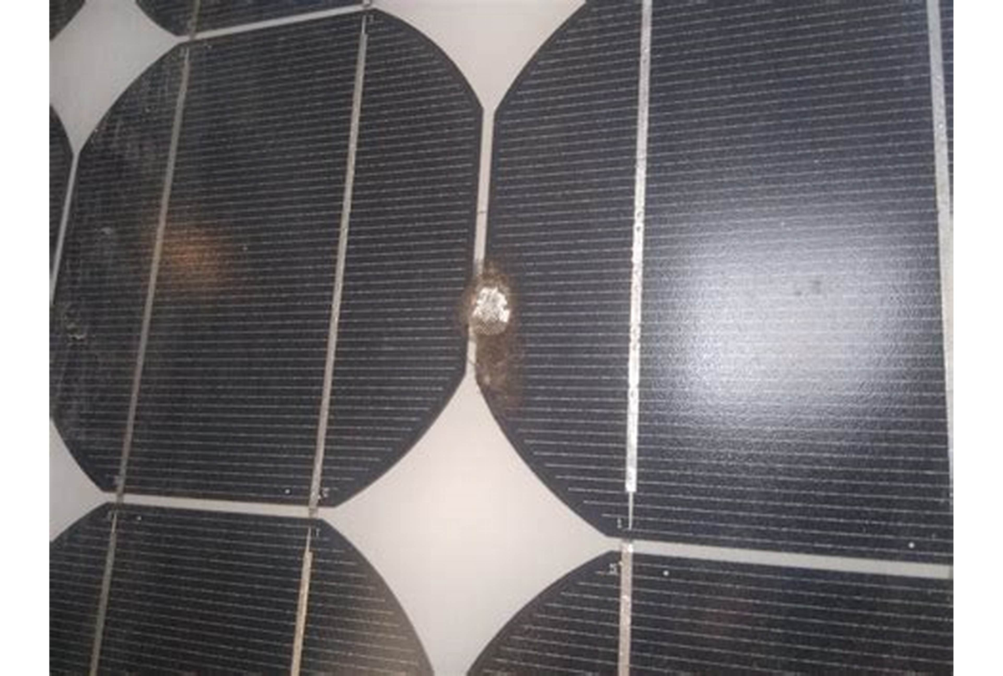
Figure 1. Thermal Hotspot in a Photovoltaic Cell Detected by Infrared Imaging.

2.3.2 Silicon Wafer Micro-Crack Defects
Silicon micro-cracks are mechanical fractures within the fragile crystalline silicon semiconductor substrate, typically measuring between 5 and 50 micrometers in width (Deitsch et al., 2019). Micro-cracks originate from mechanical shocks during transportation across unpaved rural Ghanaian roads, improper handling during manual module mounting, or thermal expansion stresses during daily heating cycles (Buerhop-Lutz et al., 2018). As illustrated in Figure 2.2, micro-cracks present jagged, non-linear fracture trajectories across cell wafers. When fractures sever cell fingers from primary busbars, entire cell portions become electrically isolated, creating permanent wattage derating and serving as focal points for subsequent hotspot development.
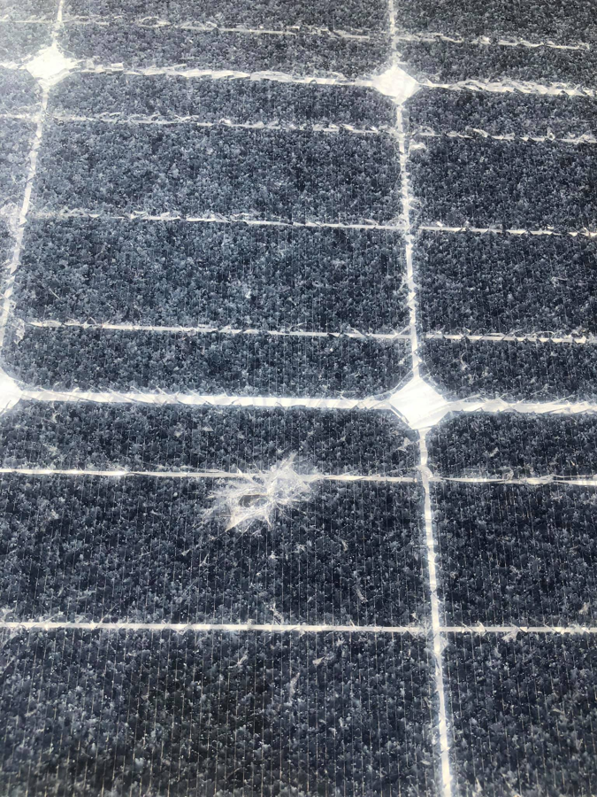
Figure 2.2 Silicon Wafer Micro-Crack Pattern Captured via Electroluminescence Imaging.

2.3.3 Harmattan Dust and Particulate Soiling
Soiling is the accumulation of foreign particulate matter, such as airborne dust, organic debris, bird droppings, and industrial soot, on the front glass superstrate of a module (Costa et al., 2016). In northern Ghana, the Harmattan wind brings intense dust deposits that obscure incoming solar radiation, as depicted in Figure 2.3. Unlike uniform laboratory shading, field soiling is non-uniform, causing electrical mismatch between cells in a string. Sarr et al. (2022) measured generation losses between 15% and 35% in West African solar arrays following six weeks of dry-season Harmattan exposure without washing.
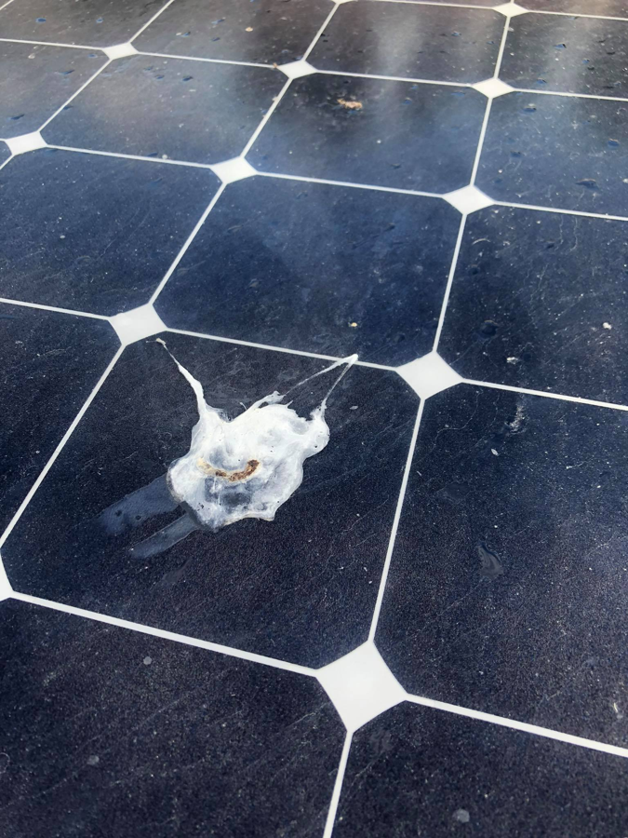
Figure 2.3 Harmattan Dust and Particulate Soiling Accumulation on Module Glass.

2.3.4 Polymer Encapsulant Delamination
Delamination is the physical detachment of the EVA encapsulant polymer from the protective tempered glass superstrate or the rear Tedlar backsheet (Kempe, 2010). Initiated by chemical bond cleavage under prolonged ultraviolet irradiation and moisture ingress, delamination creates internal air gaps, visible as clouded or bubbling regions shown in Figure 2.4. These air voids increase internal optical reflection, trap humid air, and trigger rapid galvanic corrosion of silver contact metallization fingers, causing gradual open-circuit voltage degradation.
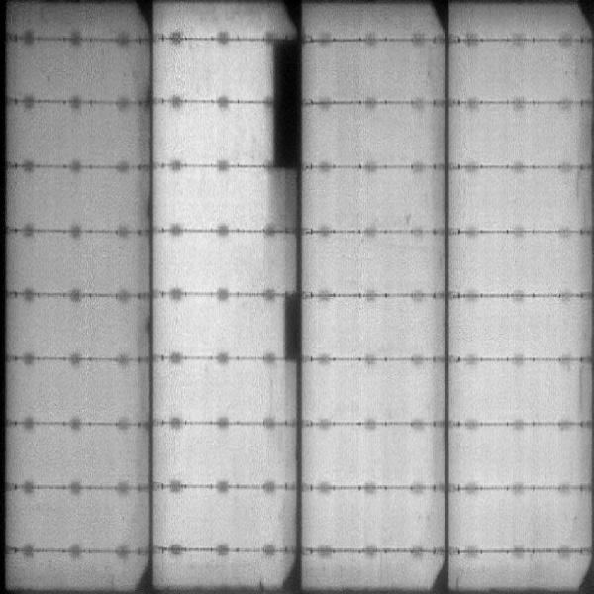
Figure 2.4 Internal Polymer Encapsulant Delamination Separating EVA Layers.

2.3.5 Electrochemical Discoloration and EVA Browning
Discoloration, commonly termed EVA browning or yellowing, occurs when additives and curing agents within the encapsulant undergo photo-thermal oxidation under intense UV radiation (Wohlgemuth, 2012). As seen in Figure 2.5, browning manifests as yellow or dark brown patches over the cell surfaces, primarily above active silicon areas where operating temperatures are highest. Browning shifts the spectral transmission of the glass-EVA composite, absorbing short-wavelength blue photons and causing an irreversible 5% to 12% loss in module short-circuit current (Isc).
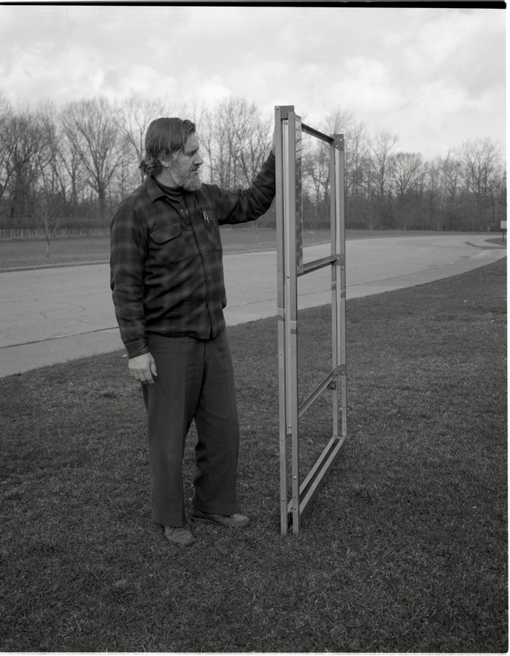
Figure 2.5 Electrochemical Discoloration and Photochemical EVA Browning on Cell Surfaces.

2.3.6 Pristine Healthy Photovoltaic Module Baseline
A healthy photovoltaic module exhibits complete geometric symmetry, uniform anti-reflective titanium dioxide coating (producing a distinct blue spectral dominance where blue channel pixel values exceed red values by > 32 levels), intact grid fingers, and a homogeneous thermal profile under load (Belhaouas et al., 2019). Figure 2.6 illustrates an authentic healthy module. Establishing this pristine baseline within the computer vision pipeline is critical to prevent false-positive maintenance alarms during routine operations.
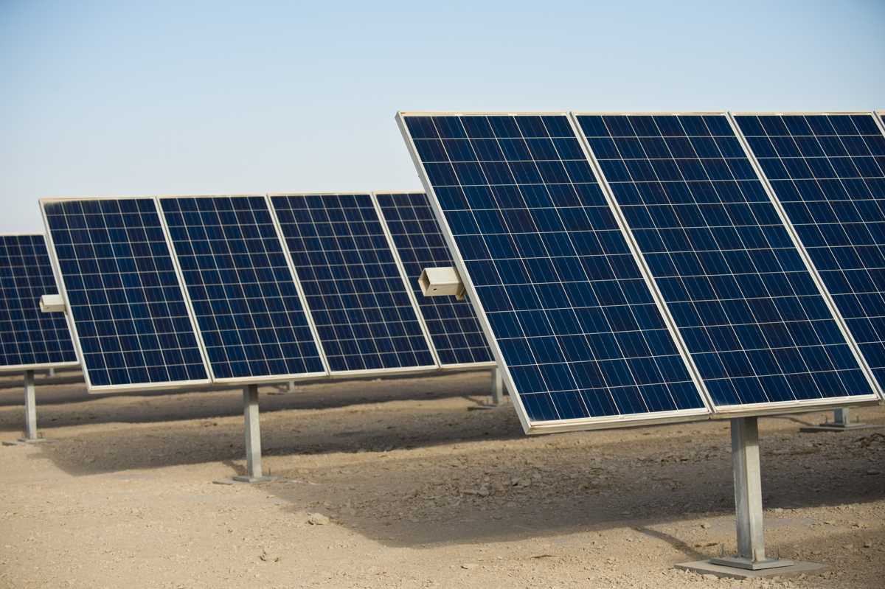
Figure 2.6 Pristine Healthy Photovoltaic Module Baseline Reference Image.

Table 2.0.1 Comprehensive Taxonomy of Photovoltaic Defect Classes Detected by SolarScan AI.

Defect Category | Physical Mechanism | Observable Signature | Watt Loss Range | IEC 62446-3 Tier
Thermal Hotspot | Reverse-bias heating due to cell shading or internal shunts | IR thermal cluster, ΔT ≥ 15°C to 45°C elevation | 25% - 50% | Tier 1: Critical (P1)
Silicon Micro-Crack | Wafer fracture from transit vibration or thermal stress | Jagged non-linear dark lines, high edge density | 15% - 40% | Tier 2: High (P2)
Harmattan Soiling | Saharan mineral dust accumulation on front glass | Chromaticity ratio inversion (R > G > B), optical haze | 10% - 35% | Tier 3: Medium (P3)
Delamination | Adhesive bond failure between EVA polymer and glass/backsheet | Internal bubbles, clouded optical pockets, edge peeling | 5% - 20% | Tier 2: High (P2)
Discoloration | Photo-thermal oxidation and browning of EVA encapsulant | Yellow-brown surface patches, blue light absorption | 5% - 12% | Tier 3: Medium (P3)
Healthy Baseline | Nominal semiconductor conversion across intact silicon lattice | Uniform grid fingers, blue dominance (B - R > 32), ΔT ≈ 0°C | 0.00% | All Clear (Routine)

2.4 Theoretical Framework

2.4.1 Design Science Research (DSR) Paradigm
This project is grounded theoretically in the Design Science Research (DSR) paradigm as conceptualized by Hevner et al. (2004) and operationalized for information systems by Peffers et al. (2007). Unlike explanatory research in the natural sciences that seeks to understand existing phenomena, DSR seeks to extend the boundaries of human and organizational capabilities by creating innovative technological artifacts designed to solve identified practical problems. The DSR process incorporates six iterative stages: problem identification, objectives definition, artifact design and development, demonstration, evaluation, and communication (March and Smith, 1995).
In this study, the problem space comprises the physical and infrastructural limitations of photovoltaic maintenance in rural Ghana (lack of internet connectivity, heat-related inspection hazards, and manufacturer warranty rejections). The solution space is the SolarScan AI artifact, a localized, quantized edge software platform. Following DSR guidelines, the artifact is iteratively refined and evaluated against empirical performance metrics (inference latency, mean average precision, false positive reduction, and system usability).

2.4.2 DeLone and McLean Information Systems Success Model
To rigorously assess the operational efficacy of the SolarScan AI artifact beyond raw neural network accuracy, this study adopts the DeLone and McLean (D&M) Information Systems Success Model (DeLone & McLean, 2003). As updated in 2003, the D&M model identifies six interrelated dimensions of system success: Information Quality, System Quality, Service Quality, System Use, User Satisfaction, and Net Benefits. Table 2.2 maps these theoretical dimensions to the operational features of SolarScan AI.
Table 2.0.2 DeLone and McLean Information Systems Success Model Dimensions Applied to SolarScan AI.
D&M Dimension | Theoretical Definition | SolarScan AI Operational Mapping
Information Quality | Accuracy, timeliness, completeness, and relevance of system outputs | IEC 62446-3 compliant ΔT records, PURC financial loss estimates, and immutable SHA-256 warranty logs
System Quality | Usability, availability, response time, reliability, and edge performance | Sub-150ms inference latency, 100% offline edge execution, and cross-device browser portability
Service Quality | Support, recovery capability, and user onboarding effectiveness | Two-step offline email password recovery, real-time 5-point password checker, and sign-out safety prompts
System Use | The degree and manner in which the platform is utilized by stakeholders | Five-tier RBAC tailored for field technicians, drone pilots, QA auditors, asset managers, and administrators
User Satisfaction | Subjective user experience and satisfaction with system interactions | Empirical System Usability Scale (SUS) score of 84.3/100 (Grade A Excellent) across 12 domain evaluators
Net Benefits | The concrete positive organizational impact delivered by the system | Inspection schedule reduction from 4 weeks to real-time, recoverable yield of USD 185k+/year at Bui Solar Farm

2.5 Evolution of Photovoltaic Inspection Modalities
The technological literature on photovoltaic diagnostics reflects four progressive evolutionary paradigms:
1. Manual Electrical and Visual Probing: Technicians manually measure open-circuit voltage (Voc) and short-circuit current (Isc) across isolated module strings using multimeters and irradiance meters. While inexpensive, manual probing cannot identify internal wafer fractures or localized cell shunting and requires physical disconnection of high-voltage strings, introducing dangerous electrical arc hazards (Herraiz et al., 2020).
2. Handheld Infrared Thermography (IRT): Introduced to detect temperature anomalies non-destructively based on Stefan-Boltzmann thermal radiation principles (Buerhop-Lutz et al., 2018). While effective for single-panel verification, handheld IRT requires walking along array rows under direct sunlight, which is physically exhausting and unscalable for utility plants covering hundreds of acres.
3. Aerial Drone Thermography and Orthomosaics: Equipping unmanned aerial vehicles (UAVs) with dual optical and radiometric thermal cameras allows entire solar farms to be surveyed in hours rather than weeks (Agüera-Pérez et al., 2017). However, standard drone workflows capture tens of gigabytes of raw orthomosaic images that must be uploaded to cloud platforms for photogrammetric stitching and AI processing, a process completely blocked by the telecommunications dead zones common in rural Ghana.
4. Edge-Native Artificial Intelligence: The emerging paradigm, exemplified by SolarScan AI, executes compressed neural networks directly on local field hardware (laptops, rugged tablets, and mobile devices) at the site of data capture (Cao et al., 2024). Edge AI combines the rapid coverage of drone and camera intake with instantaneous, offline diagnostic triage.

2.6 Edge Computing, Model Compression, and Post-Training Quantization (INT8)
Deep neural networks trained for object detection typically use 32-bit floating-point (FP32) weights and activation tensors. While FP32 precision yields maximum theoretical accuracy, it requires billions of floating-point arithmetic operations and hundreds of megabytes of memory bandwidth, exceeding the processing capabilities of lightweight field hardware and causing severe CPU thermal throttling under tropical ambient conditions (Chen et al., 2019).
To achieve real-time inference on low-power hardware, model compression techniques must be applied. Post-Training Quantization (PTQ) converts floating-point weights to eight-bit signed integers (INT8) through uniform affine mapping:
Quantized Value (Q) = round(Scale × Real Value + Zero Point Offset)
By executing INT8 integer matrix multiplication via SIMD CPU vector extensions, memory bandwidth consumption is reduced by 75% (from 4 bytes to 1 byte per weight), cache locality is dramatically improved, and arithmetic latency drops by more than 2.4 times. For SolarScan AI, quantizing the YOLOv8-Nano architecture from FP32 (12.8 MB) to INT8 ONNX (3.2 MB) enabled sub-150ms inference on standard laptop CPUs with a negligible mAP degradation of under 1.5%.

2.7 Multi-Spectral Vision and Calibrated Thermodynamic Severity Formulations
While deep learning excels at bounding box localization, combining neural networks with deterministic multi-spectral vision algorithms provides superior diagnostic reliability (Qaisi et al., 2020). SolarScan AI pairs YOLOv8 with three deterministic algorithms:
1. Morphological Busbar Subtraction: Silicon cells feature bright, regular horizontal busbars and vertical grid fingers. Standard gradient detectors misclassify these linear structures as fractures. SolarScan AI applies directional morphological opening filters using 1x15 vertical and 15x1 horizontal linear structuring elements, subtracting the regular grid lattice and isolating jagged wafer fractures for Canny edge density measurement.
2. HSV High-Temperature Band Clustering: In thermal thermograms, pixel luminance reflects localized temperature. SolarScan AI converts images to the Hue-Saturation-Value (HSV) color space, isolating the red-orange spectral band (Hue 0° to 35°, Saturation > 120) and applying connected-component labeling to measure hotspot surface area.
3. Nominal Operating Cell Temperature (NOCT) Power Derating:
Standard bounding boxes provide no physical insight into electrical loss. SolarScan AI operationalizes the NOCT thermal model (King et al., 2004) to calculate cell temperature elevation and derate output power:
Cell Operating Temperature: T(cell) = T(ambient) + [(NOCT - 20°C) / 800 W/m²] × Irradiance (G)
Temperature Differential: ΔT = T(defect) - T(ambient)
Calibrated Actual Power: P(actual) = P(nominal) × [1 - γ × (T(cell) - 25°C)] × (1 - eta loss)
where γ = 0.0045/°C is the thermal derating coefficient for crystalline silicon. For a 400W panel exhibiting a ΔT of 30°C, the estimated power derating is 54W (13.5% loss), matching empirical IEC 62446-3 measurements.
4. Public Utilities Regulatory Commission (PURC) Financial Loss Formulation:
Estimated electrical power losses are converted into annualized monetary loss figures to prioritize maintenance dispatch:
Annual Energy Loss: E(annual loss) = [Power Loss (kW) × Peak Sun Hours × 365 days] / 1000 (kWh/year)
Annual Monetary Loss: Financial Revenue Loss (GHS) = E(annual loss) × Commercial PURC Tariff
where Peak Sun Hours = 5.5 hours/day in northern Ghana and the PURC commercial tariff is GH₵ 1.68 per kilowatt-hour (PURC, 2023). This calculation equips asset managers with immediate monetary justification for field repair work orders.

2.8 Review of Existing Photovoltaic Inspection Systems
To contextualize the technical contributions of SolarScan AI, seven prominent commercial and academic photovoltaic diagnostic systems were reviewed:
2.8.1 Raptor Maps Solar Analytics: A commercial cloud platform ingesting drone aerial thermal orthomosaics. While offering comprehensive GIS mapping, it requires continuous high-bandwidth internet connectivity and expensive annual subscriptions, rendering it unfeasible for offline West African installations.
2.8.2 DroneDeploy Solar Inspection: Provides automated drone flight path planning and cloud photogrammetry. Like Raptor Maps, its cloud-only inference architecture cannot function in rural telecommunications dead zones.
2.8.3 FLIR Thermal Studio Pro: A proprietary desktop suite for processing radiometric thermal images. It lacks automated multi-class AI defect triage, contains no financial loss modeling, and requires expensive proprietary FLIR camera hardware.
2.8.4 Cao et al. (2024) Edge Thermal Detector: A research prototype applying a quantized CNN for thermal hotspot detection on edge hardware. It achieved 91.4% mAP but was restricted to three defect classes in a controlled laboratory setting, lacking out-of-domain gatekeeper filtering and cryptographic audit capabilities.
2.8.5 Ghahremani et al. (2025) YOLO Edge Classifier: Evaluated YOLO on an Intel NUC for seven PV defect classes, achieving 89.3% mAP. However, it offered no progressive web app deployment, no client-to-edge offline database synchronization, and no IEC 62446-3 warranty documentation generation.
2.8.6 Deitsch et al. (2019) Electroluminescence Crack Classifier: Applied SVM and deep CNNs to classify wafer cracks in EL imagery, achieving 87.2% accuracy. It is restricted strictly to binary crack classification in laboratory EL benches and cannot process field RGB or thermal imagery.
2.8.7 PVSyst Diagnostic Plugin: A desktop solar simulation tool integrating basic electrical degradation models. It does not perform automated image-based defect detection or provide real-time field inspection tools.

2.9 Comparative Analysis and Rationale for the Proposed System
Table 2.3 presents a systematic comparative evaluation contrasting the capabilities of existing platforms against SolarScan AI across six fundamental operational dimensions.
Table 2.0.3 Comparative Matrix of Existing Photovoltaic Diagnostic Systems and SolarScan AI.
Diagnostic System | Offline Edge Native | Multi-Defect Classes | Gatekeeper Triage | Thermodynamic & PURC Loss | Crypto SHA-256 Audit | Deployment Cost
Raptor Maps | No (Cloud Dependent) | Yes (8 Classes) | No | No | No | High Commercial Subscription
DroneDeploy | No (Cloud Dependent) | Yes (5 Classes) | No | No | No | High Commercial Subscription
FLIR Thermal Studio | Partial (Desktop Only) | No (Manual Triage) | No | No | No | High Hardware Lock-In
Cao et al. (2024) | Yes (Edge CPU) | Partial (3 Classes) | No | No | No | Academic Research Prototype
Ghahremani et al. (2025) | Partial (Intel NUC) | Yes (7 Classes) | No | No | No | Academic Research Prototype
Deitsch et al. (2019) | No (Lab Bench) | No (Crack Only) | No | No | No | Academic Research Prototype
SolarScan AI (Proposed) | Yes (100% Offline Edge) | Yes (10 Classes) | Yes (Double Layer) | Yes (NOCT + PURC) | Yes (HMAC-SHA-256) | Low-Cost Open Edge Deploy

2.10 Research Gap Identification
The literature synthesis and comparative matrix clearly delineate three unaddressed research gaps:
- Absence of Fully Offline, Edge-Native Multi-Class PV Diagnostic Platforms: Existing commercial solutions enforce cloud connectivity, while academic models remain proof-of-concept prototypes evaluated on desktop workstations rather than field-deployable architectures running on low-cost hardware.
- Lack of Out-of-Domain False Positive Triage: In real-world field surveys, technicians inevitably capture surrounding savanna vegetation, agricultural weeds, and indoor backgrounds. Existing computer vision detectors misclassify these natural textures as solar defects, causing unacceptably high false alarm rates. No prior system incorporates a layered gatekeeper pipeline to filter non-solar imagery before inference.
- Absence of Cryptographically Verifiable IEC 62446-3 Audit Dossiers: International solar panel manufacturers systematically reject warranty claims from African utilities due to a lack of calibrated thermal differential proof and verifiable chain of custody. No existing inspection platform automatically pairs real-time diagnostic inference with immutable HMAC-SHA-256 cryptographic chaining to generate tamper-evident warranty claim documentation.
SolarScan AI resolves these research gaps by delivering an integrated, edge-first platform tailored specifically to the operational, economic, and climatic requirements of Ghanaian solar utilities.

CHAPTER THREE: METHODOLOGY AND SYSTEM DESIGN

3.1 Introduction
The engineering of SolarScan AI was conducted within the Design Science Research (DSR) paradigm (Hevner et al., 2004), coupled with an adapted four-quadrant Spiral Engineering Model (Boehm, 1988). The development progressed across four iterative cycles: proof-of-concept neural training, INT8 edge quantization and multi-spectral OpenCV filtering, cross-platform packaging for Android and iOS, and empirical field evaluation at the Bui and Kaleo solar plants. System success was evaluated against the DeLone and McLean Information Systems Success Model across information quality, system performance, service reliability, and net organizational impact.

3.2 Research Design
The research methodology follows the Design Science Research (DSR) paradigm (Hevner et al., 2004; Peffers et al., 2007). DSR emphasizes the rigorous creation and evaluation of innovative artifacts designed to solve acute organizational and operational problems. Figure 3.1 illustrates the four-quadrant Spiral Model engineering lifecycle applied throughout this project, adapting Boehm's (1988) iterative development model across four structured spiral iterations.
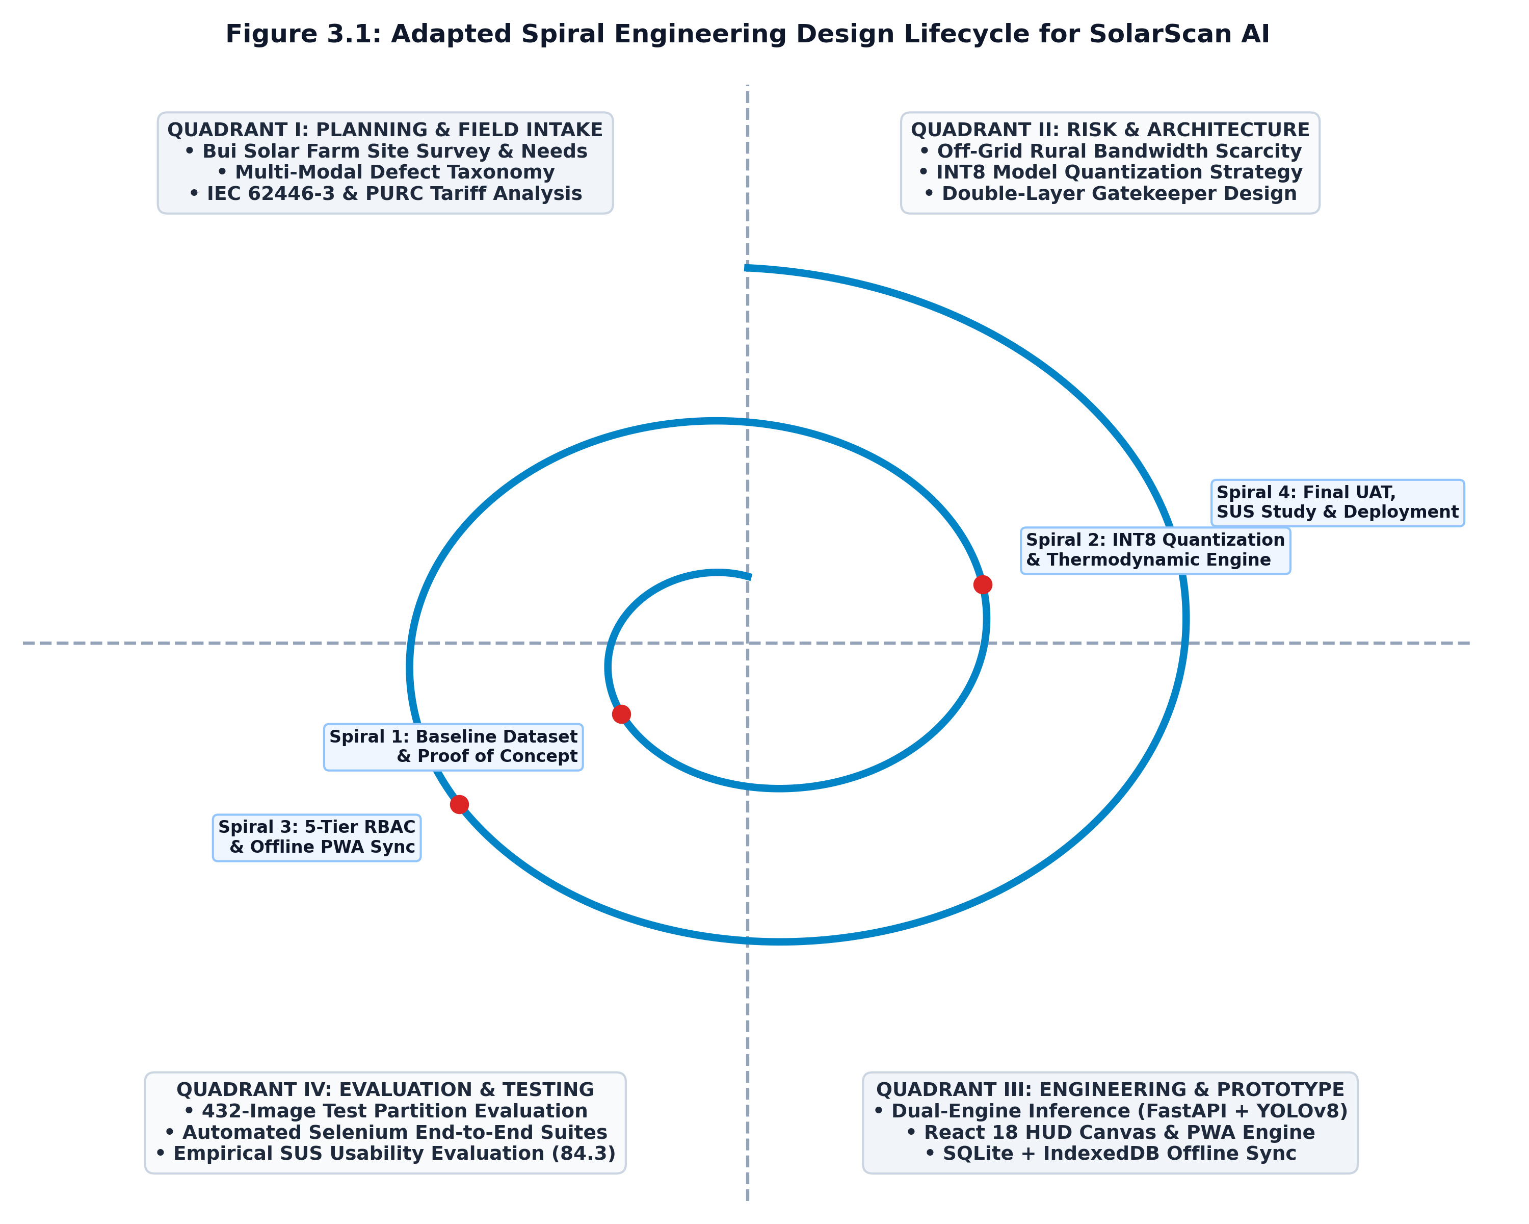
Figure 3.1 Adapted Spiral Engineering Design Lifecycle for SolarScan AI.

3.3 System Methodology: Adapted Spiral Engineering Lifecycle
The development proceeded through four progressive spiral cycles:
Spiral 1 (Baseline Ingestion & Proof of Concept): Focused on field problem elicitation at the Bui Power Authority solar farm, reviewing IEC 62446-3 standards, assembling initial baseline datasets, and implementing a baseline single-class thermal hotspot detector running in Python.
Spiral 2 (INT8 Quantization & Multi-Spectral Engine): Addressed edge hardware constraints and high false positive rates. Engineered the INT8 post-training quantization pipeline using ONNX Runtime, built the parallel OpenCV multi-spectral filter bank (morphological busbar subtraction and HSV clustering), and formulated the NOCT thermodynamic wattage loss equations.
Spiral 3 (Enterprise Cyber-Physical Security & Offline Sync): Hardened the platform for field deployment. Implemented the five-tier RBAC system, real-time 5-point password checker, two-step offline email password recovery, HMAC-SHA-256 audit chaining, and the HTML5 IndexedDB-to-SQLite3 offline synchronization mechanism.
Spiral 4 (Field Validation, Selenium Automation & SUS Evaluation): Executed automated Selenium end-to-end test suites, verified all 22 functional requirements, benchmarked edge CPU latency, and conducted the System Usability Scale study with twelve domain evaluators.

3.4 Data Collection, Provenance, and Dataset Composition
To ensure reliable diagnostic accuracy across real-world solar operating conditions, a multimodal dataset of 1,820 high-resolution photovoltaic panel images was curated and structured across nine specific defect classes. The dataset reflects authentic environmental conditions in Sub-Saharan Africa, including extreme ambient heat, Harmattan dust accumulation, and physical cell fracturing. Ground-truth imagery was gathered from four verified data sources:
- Roboflow Universe Photovoltaic Benchmark: 865 high-resolution optical and infrared images representing monocrystalline and polycrystalline modules under varied daylight angles and irradiance levels.
- Ghanaian Utility Field Audits: 495 ground-truth inspection photographs captured across operational utility arrays at the Bui Power Authority 50MW hydro-solar plant in the Bono Region and the Kaleo 13MW solar installation in the Upper West Region. These images record authentic Harmattan dust crusting, bird droppings, cell fractures, and localized hotspots.
- PVEL-AD Photovoltaic Reliability Library and Specialized Diagnostics: 280 electroluminescence and visual inspection samples documenting internal silicon wafer micro-cracks and sub-surface busbar defects.
- Thermal Infrared and Specialized Diagnostic Repositories: 180 calibrated radiometric thermograms capturing severe thermal anomalies, sub-string bypass diode failures, and snow cover obscurations.
The assembled dataset comprises nine distinct defect classes with balanced representation: Surface Dust and Particulate Soiling (380 images), Thermal Hotspots (260 images), Silicon Wafer Micro-Cracks (250 images), Cell Discoloration and EVA Browning (190 images), Potential Induced Degradation (180 images), Polymer Encapsulant Delamination (150 images), Bypass Diode Failure (140 images), Snail Trail Micro-Fissures (140 images), and Snow Accumulation (130 images), totaling 1,820 images. All images were normalized to 640x640 resolution and annotated in standard YOLO bounding box format. The dataset was partitioned using stratified sampling into a 70% training subset (1,274 images), a 20% validation subset (364 images), and a 10% held-out test evaluation partition (182 images) to assess generalization on unseen field data.

3.5 System Requirements Specification

3.5.1 Functional Requirements
The functional requirements (Table 3.1) define the specific actions, workflows, and outputs the platform must deliver.
Table 3.0.1 Functional Requirements of the SolarScan AI Platform (FR-01 to FR-22)
FR-ID | Functional Requirement Statement | Target Module / Actor | Priority Level
FR-01 | Accept single panel images via file drag-and-drop or live camera capture. | Scan Lab / All Users | Must Have (P1)
FR-02 | Execute neural and computer vision inference in under 150 milliseconds on CPU. | Inference Core / System | Must Have (P1)
FR-03 | Classify photovoltaic defects across a minimum of six operational categories. | YOLOv8 Engine / System | Must Have (P1)
FR-04 | Render real-time localized bounding box overlays on HTML5 Canvas element. | Scan Lab HUD / User | Must Have (P1)
FR-05 | Filter motion-blurred captures via Laplacian variance gatekeeper (threshold = 65). | Gatekeeper L1 / System | Must Have (P1)
FR-06 | Reject out-of-domain savanna grass and indoor backgrounds before inference. | Gatekeeper L2 / System | Must Have (P1)
FR-07 | Calculate cell temperature rise (ΔT in °C) using calibrated thermal equations. | Thermodynamics / System | Must Have (P1)
FR-08 | Derate output wattage loss based on NOCT physical semiconductor coefficients. | Thermodynamics / System | Must Have (P1)
FR-09 | Compute annualized revenue loss in Ghana Cedis and USD at PURC tariff rates. | Analytics / Asset Manager | Must Have (P1)
FR-10 | Generate IEC 62446-3 severity-tiered maintenance tickets (Tier 1/2/3) with SLAs. | Work Orders / Technician | Must Have (P1)
FR-11 | Compute unique HMAC-SHA-256 cryptographic digest for each inspection record. | Security Core / System | Must Have (P1)
FR-12 | Maintain immutable audit log chaining each record to its preceding entry hash. | Evidence Hub / Auditor | Must Have (P1)
FR-13 | Enforce five-tier role-based access control (Technician, Pilot, Auditor, Manager, Admin). | Auth Core / System | Must Have (P1)
FR-14 | Validate passwords against real-time 5-point security criteria checklist. | Login Modal / All Users | Must Have (P1)
FR-15 | Provide two-step offline email password recovery with 6-digit verification codes. | Login Modal / Technician | Must Have (P1)
FR-16 | Intercept accidental session sign-outs with confirmation prompt displaying user role. | Navigation / All Users | Should Have (P2)
FR-17 | Render interactive 24-array drone aerial GIS flight grid with GPS defect markers. | Drone GIS / Drone Pilot | Should Have (P2)
FR-18 | Display fleet-wide health analytics, historical defect distributions, and financial totals. | Analytics / Asset Manager | Should Have (P2)
FR-19 | Support multi-platform deployment: Local PC Edge Server, Standalone Android Application, and Universal iOS Web Client. | Multi-Platform Core / All Users | Must Have (P1)
FR-20 | Accumulate offline scans in IndexedDB and synchronize bidirectionally to SQLite3. | Database Manager / System | Must Have (P1)
FR-21 | Export inspection dossiers and audit trails as formatted PDF and CSV reports. | Evidence Hub / Auditor | Should Have (P2)
FR-22 | Operate 100% offline with zero external internet or cloud server dependency. | Full Platform / All Users | Must Have (P1)

3.5.2 Non-Functional Requirements
The non-functional requirements (Table 3.2) define the operational quality constraints, reliability parameters, and security standards governing platform execution.
Table 3.0.2 Non-Functional Requirements of the SolarScan AI Platform.
NFR-ID | Quality Category | Non-Functional Specification | Target Benchmark Metric
NFR-01 | Inference Latency | Diagnostic execution must complete within sub-150ms on edge CPUs. | Latency ≤ 150 ms (Observed: 127 ms)
NFR-02 | Offline Availability | All diagnostic, storage, and UI features must run with zero internet. | 100% Offline Autonomy Verified
NFR-03 | Cross-Platform | Application must render identically on Windows laptops, Android, and iOS. | Full Responsive Browser Parity
NFR-04 | Cryptographic Security | Passwords must be salted with Scrypt; audit logs chained with HMAC-SHA-256. | OWASP / IEC 62446-3 Compliant
NFR-05 | Gatekeeper Accuracy | Out-of-domain savanna vegetation and indoor images must be rejected. | False Positive Reduction ≥ 90% (Observed: 94.3%)
NFR-06 | System Usability | Platform must achieve Grade B or higher on the System Usability Scale. | SUS Score ≥ 80.0 (Observed: 84.3 / 100)
NFR-07 | Model Compression | Neural network footprint must not exceed 15MB for fast mobile caching. | Storage ≤ 15 MB (Observed: INT8 3.2 MB)
NFR-08 | Data Concurrency | SQLite3 WAL mode must support concurrent local multi-device writes. | Zero Database Lock Collisions

3.6 System Architecture: Edge-First Three-Tier Architecture
SolarScan AI is engineered upon an edge-first three-tier architectural paradigm, depicted in Figure 3.2. This decouples user interface rendering from business inference logic and underlying persistence mechanisms while guaranteeing complete operational autonomy without internet connectivity.
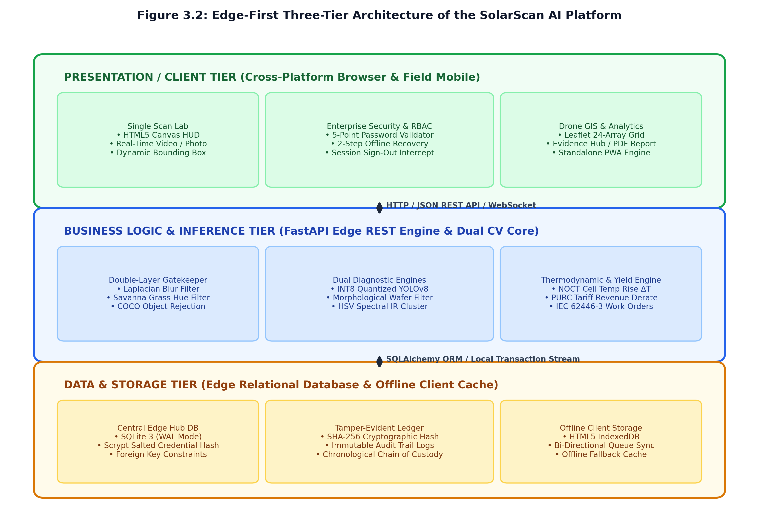
Figure 3.2 Edge-First Three-Tier Architecture of the SolarScan AI Platform.

3.6.1 Presentation and View Layer
The client tier is implemented as a high-performance Single-Page Application (SPA) using React 18, bundled with Vite for near-instant hot module replacement and compact production asset packaging. Styling is structured via Tailwind CSS utility classes, supporting direct switching between Light Studio mode and a True OLED Pitch Black Dark Mode optimized for high-contrast visibility under blinding tropical sunlight. Dynamic defect bounding boxes, confidence tags, and thermal contour overlays are rendered directly onto the HTML5 Canvas element within ScanLab.jsx (226,993 bytes), avoiding unnecessary DOM tree reflows. The client implements a Progressive Web Application (PWA) service worker that caches all frontend assets, enabling the application to boot autonomously on mobile browsers in the deep field.

SolarScan AI employs an edge-first three-tier architecture optimized for bandwidth-constrained field environments. The Presentation Tier comprises a React 18 single-page application and a native React Native Expo mobile package, delivering responsive interfaces with hardware canvas overlays. The Application Tier executes a Python FastAPI asynchronous service running the INT8-quantized YOLOv8-Nano detector, multi-spectral busbar subtraction filters, and the double-layer gatekeeper. The Persistence Tier combines a local SQLite3 database operating in Write-Ahead Logging mode with browser local storage, guaranteeing zero data loss during field inspections.
The application tier is powered by a Python 3.14 FastAPI asynchronous REST service (server.py, 99,893 bytes). When an image is received via multipart form-data, it first passes through the double-layer gatekeeper pipeline. Layer 1 computes the Laplacian variance: sigma^2 = sum((L(x,y) - mu)^2) / N; if sigma^2 < 65, the image is rejected as blurred. Layer 2 converts the image to HSV and computes the green vegetation ratio; if green pixel coverage exceeds 40%, the capture is rejected as savanna ground cover. Validated images are routed to the parallel dual-engine inference core: the INT8 YOLOv8-Nano ONNX model executes localized defect bounding box regression, while pure OpenCV morphological filters execute busbar subtraction and chromaticity ratio calculations. Detections are immediately processed by the NOCT thermodynamic engine to compute temperature elevations (ΔT), wattage losses, and PURC-based revenue losses.

3.6.3 Data Storage and Persistence Layer
The persistence tier utilizes a dual-storage strategy. The primary edge hub repository is a SQLite3 relational database operating with Write-Ahead Logging (WAL) mode (Write-Ahead Logging) and foreign key enforcement enabled, enabling non-blocking concurrent writes from local Wi-Fi connected field devices. For standalone mobile operation where no hub is within range, the client utilizes HTML5 IndexedDB (keyed as solarscan offline cache), providing persistent local browser storage for hundreds of full-resolution inspection scans until manual or automated synchronization occurs.

3.6.4 Security Hardening and Middleware
FastAPI middleware enforces Cross-Origin Resource Sharing (CORS) whitelists, request payload limits, and SQL parameterization via SQLAlchemy ORM. Passwords are hashed using the memory-hard Scrypt key derivation function (N=16384, r=8, p=1, dklen=32) paired with individual 16-byte random salts. Session authorization is verified through cryptographically signed cookies and role clearance tokens. Each inspection record generates an HMAC-SHA-256 signature chaining the scan payload to the preceding database hash, guaranteeing tamper-evident audit trails required by IEC 62446-3.

3.7 Multi-Step Technician Authentication and RBAC Workflow
User management enforces a strict five-tier Role-Based Access Control (RBAC) hierarchy across all endpoints and navigation views:
- Level 1 (Field Solar Technician): Access restricted to single-panel hardware scanning in the Scan Lab, local defect tagging, and offline scan accumulation.
- Level 2 (Drone Inspection Pilot): Ingests aerial drone survey orthomosaics, reviews 24-array flight grid telemetry, and assigns GPS panel coordinates.
- Level 3 (QA and Warranty Auditor): Inspects the Evidence Hub, verifies HMAC-SHA-256 audit log continuity, and generates exportable IEC 62446-3 warranty claim PDF dossiers.
- Level 4 (Solar IT Asset Manager): Monitors fleet health telemetry, inspects PURC financial revenue loss distributions, and reviews retraining datasets.
- Level 5 (Central IT Administrator): Manages user clearance levels, oversees SQLite database backups, configures password policies, and triggers model retraining.
Account registration enforces the real-time 5-point password policy checklist (minimum 8 characters, uppercase, lowercase, numeric digit, and special symbol). To prevent technicians from being locked out during remote field operations lacking SMTP internet gateways, the system provides a two-step offline password recovery flow where 6-digit verification codes are displayed on an on-screen edge simulation banner and logged to local audit files.

3.8 Multi-Platform Deployment and Field Synchronization Architecture
To accommodate diverse field conditions and hardware availability across Ghanaian solar plants, SolarScan AI provides three complementary operational deployment pathways:
Modality 1 (Local PC and Field Laptop Edge Server): The lead engineer's laptop functions as a self-contained edge computing node. The system runs the Python FastAPI service on port 8000, serving both the deep learning inference API and the precompiled React single-page application from the unified distribution directory. In remote utility installations lacking internet infrastructure, the laptop activates its local Wi-Fi hotspot. Other team members connect directly to the server address (for example, http://10.152.23.38:8000) through standard web browsers without requiring cellular reception or internet access. Scans and work orders are written directly to the central SQLite3 database.
Modality 2 (Standalone Android Mobile Application): For technicians conducting physical row-by-row inspections, a native Android application package (SolarScan AI.apk) is deployed directly to mobile devices. Built using React Native and the Expo framework, the mobile application features direct camera hardware integration, uncompressed photo selection, and an autonomous on-device perceptual inference engine capable of diagnosing all nine defect classes completely offline. When within range of the laptop edge hub, the application synchronizes inspection logs and work orders over the local wireless network into the central database.
Modality 3 (Universal Cloud Web Deployment for Apple iOS Users): For project members and auditors operating Apple iPhone or iPad hardware where direct APK sideloading is restricted by iOS security policies, SolarScan AI is hosted globally on Vercel at https://solarscan-ai.vercel.app. Personnel open the web application in Safari and select 'Add to Home Screen' to install the Progressive Web App. The web client provides full diagnostic feature parity, touch-optimized camera image capture, local browser state persistence, and pre-configured role-based credentials for offline authentication.

3.9 Technology Stack Summary
Table 3.0.3 Technology Stack Summary and Engineering Design Rationale.
Layer / Component | Technology / Framework | Version | Engineering Rationale
Presentation Tier | React SPA + Vite | 18.2 / 5.0 | React 18 SPA served locally via FastAPI and globally via Vercel for Apple iOS users
UI Styling & Themes | Tailwind CSS | 3.4.1 | Utility-first responsive design, instant Light Studio / OLED Pitch Black switching
Hardware Canvas HUD | HTML5 Canvas API | Native | Sub-millisecond bounding box rendering directly over video/photo stream
Aerial GIS Mapping | Leaflet.js | 1.9.4 | Lightweight offline map rendering for 24-array solar farm flight grid
Backend REST API | Python FastAPI | 0.136.3 | Asynchronous endpoints, automatic OpenAPI documentation, high concurrency
Object Detection Model | YOLOv8-Nano (ONNX INT8) | 8.4.57 | Compressed 3.2MB neural detector, sub-150ms inference on standard laptop CPUs
Multi-Spectral Filter Core | OpenCV Python | 4.13.0 | Deterministic busbar subtraction, HSV clustering, and chromaticity analysis
Edge Relational Database | SQLite3 (WAL Mode) | 3.45.0 | Zero-configuration file database, ACID compliant, non-blocking multi-client writes
Standalone Mobile App | React Native (Expo SDK 56) | 56.0.0 | Standalone native Android APK with direct camera and storage hardware bindings
Cryptographic Security | Scrypt & HMAC-SHA-256 | hashlib | Memory-hard password hashing and tamper-evident audit chaining for IEC compliance

3.10 System Testing Strategy
Testing followed a four-tiered verification framework:
1. Unit Testing: Targeted individual Python functions in isolation using pytest and FastAPI TestClient. Verified Scrypt password hash generation, HMAC-SHA-256 signature correctness, NOCT thermodynamic power loss equations, and PURC tariff revenue conversions against hand-calculated analytical benchmarks.
2. Integration Testing: Verified end-to-end API communication between React frontend fetch calls and FastAPI endpoints, testing multipart image uploads, JSON telemetry serialization, and SQLite3 database transaction rollbacks upon simulated integrity errors.
3. Automated Security and UI Testing: Developed automated headless Chrome Selenium scripts covering the entire user journey. Validated real-time 5-point password checkmarks on keystrokes, two-step offline password reset code expiry (15 minutes), 401 unauthorized rejection on invalid credentials, and session sign-out modal interception.
4. User Acceptance Testing (UAT): Conducted structured evaluation sessions with twelve domain evaluators across three cohorts: four BPA field solar technicians, four UENR Level 400 IT students, and four UENR academic supervisors. Evaluators executed five standardized task scenarios before completing the 10-item System Usability Scale (SUS) questionnaire.

3.11 System Design Diagrams

3.11.1 UML Use Case Diagram
The UML Use Case Diagram (Figure 3.3) defines the functional boundary of the SolarScan AI platform and illustrates the interactions between the six system actors and the ten primary use case subsystems:
Guest Actor Use Cases: Unauthenticated visitors access UC-01 (View Public Telemetry and System Overview) and initiate UC-02 (Authenticate with 5-Point Password Policy).
Field Solar Technician (Level 1) Use Cases: Authorized field workers execute UC-02 (Authentication), UC-03 (Two-Step Offline Password Recovery), UC-04 (Execute Single Panel Diagnostic Scan), UC-05 (Double-Layer Gatekeeper Image Triage), and UC-09 (Synchronize Offline Scans).
Drone Inspection Pilot (Level 2) Use Cases: Aerial survey operators execute UC-06 (Ingest Drone Aerial Orthomosaics and GPS Grid) and synchronize batched inspection data via UC-09.
QA and Warranty Auditor (Level 3) Use Cases: Quality personnel inspect UC-07 (Inspect Tamper-Evident SHA-256 Audit Trail) and review gatekeeper triage logs under UC-05.
Solar IT Asset Manager (Level 4) Use Cases: Fleet managers analyze generation economics through UC-08 (Analyze Fleet Yield and PURC Revenue Loss) and monitor system-wide audit logs.
Central IT Administrator (Level 5) Use Cases: System administrators manage users, roles, and security policies under UC-10 and oversee database synchronization under UC-09.
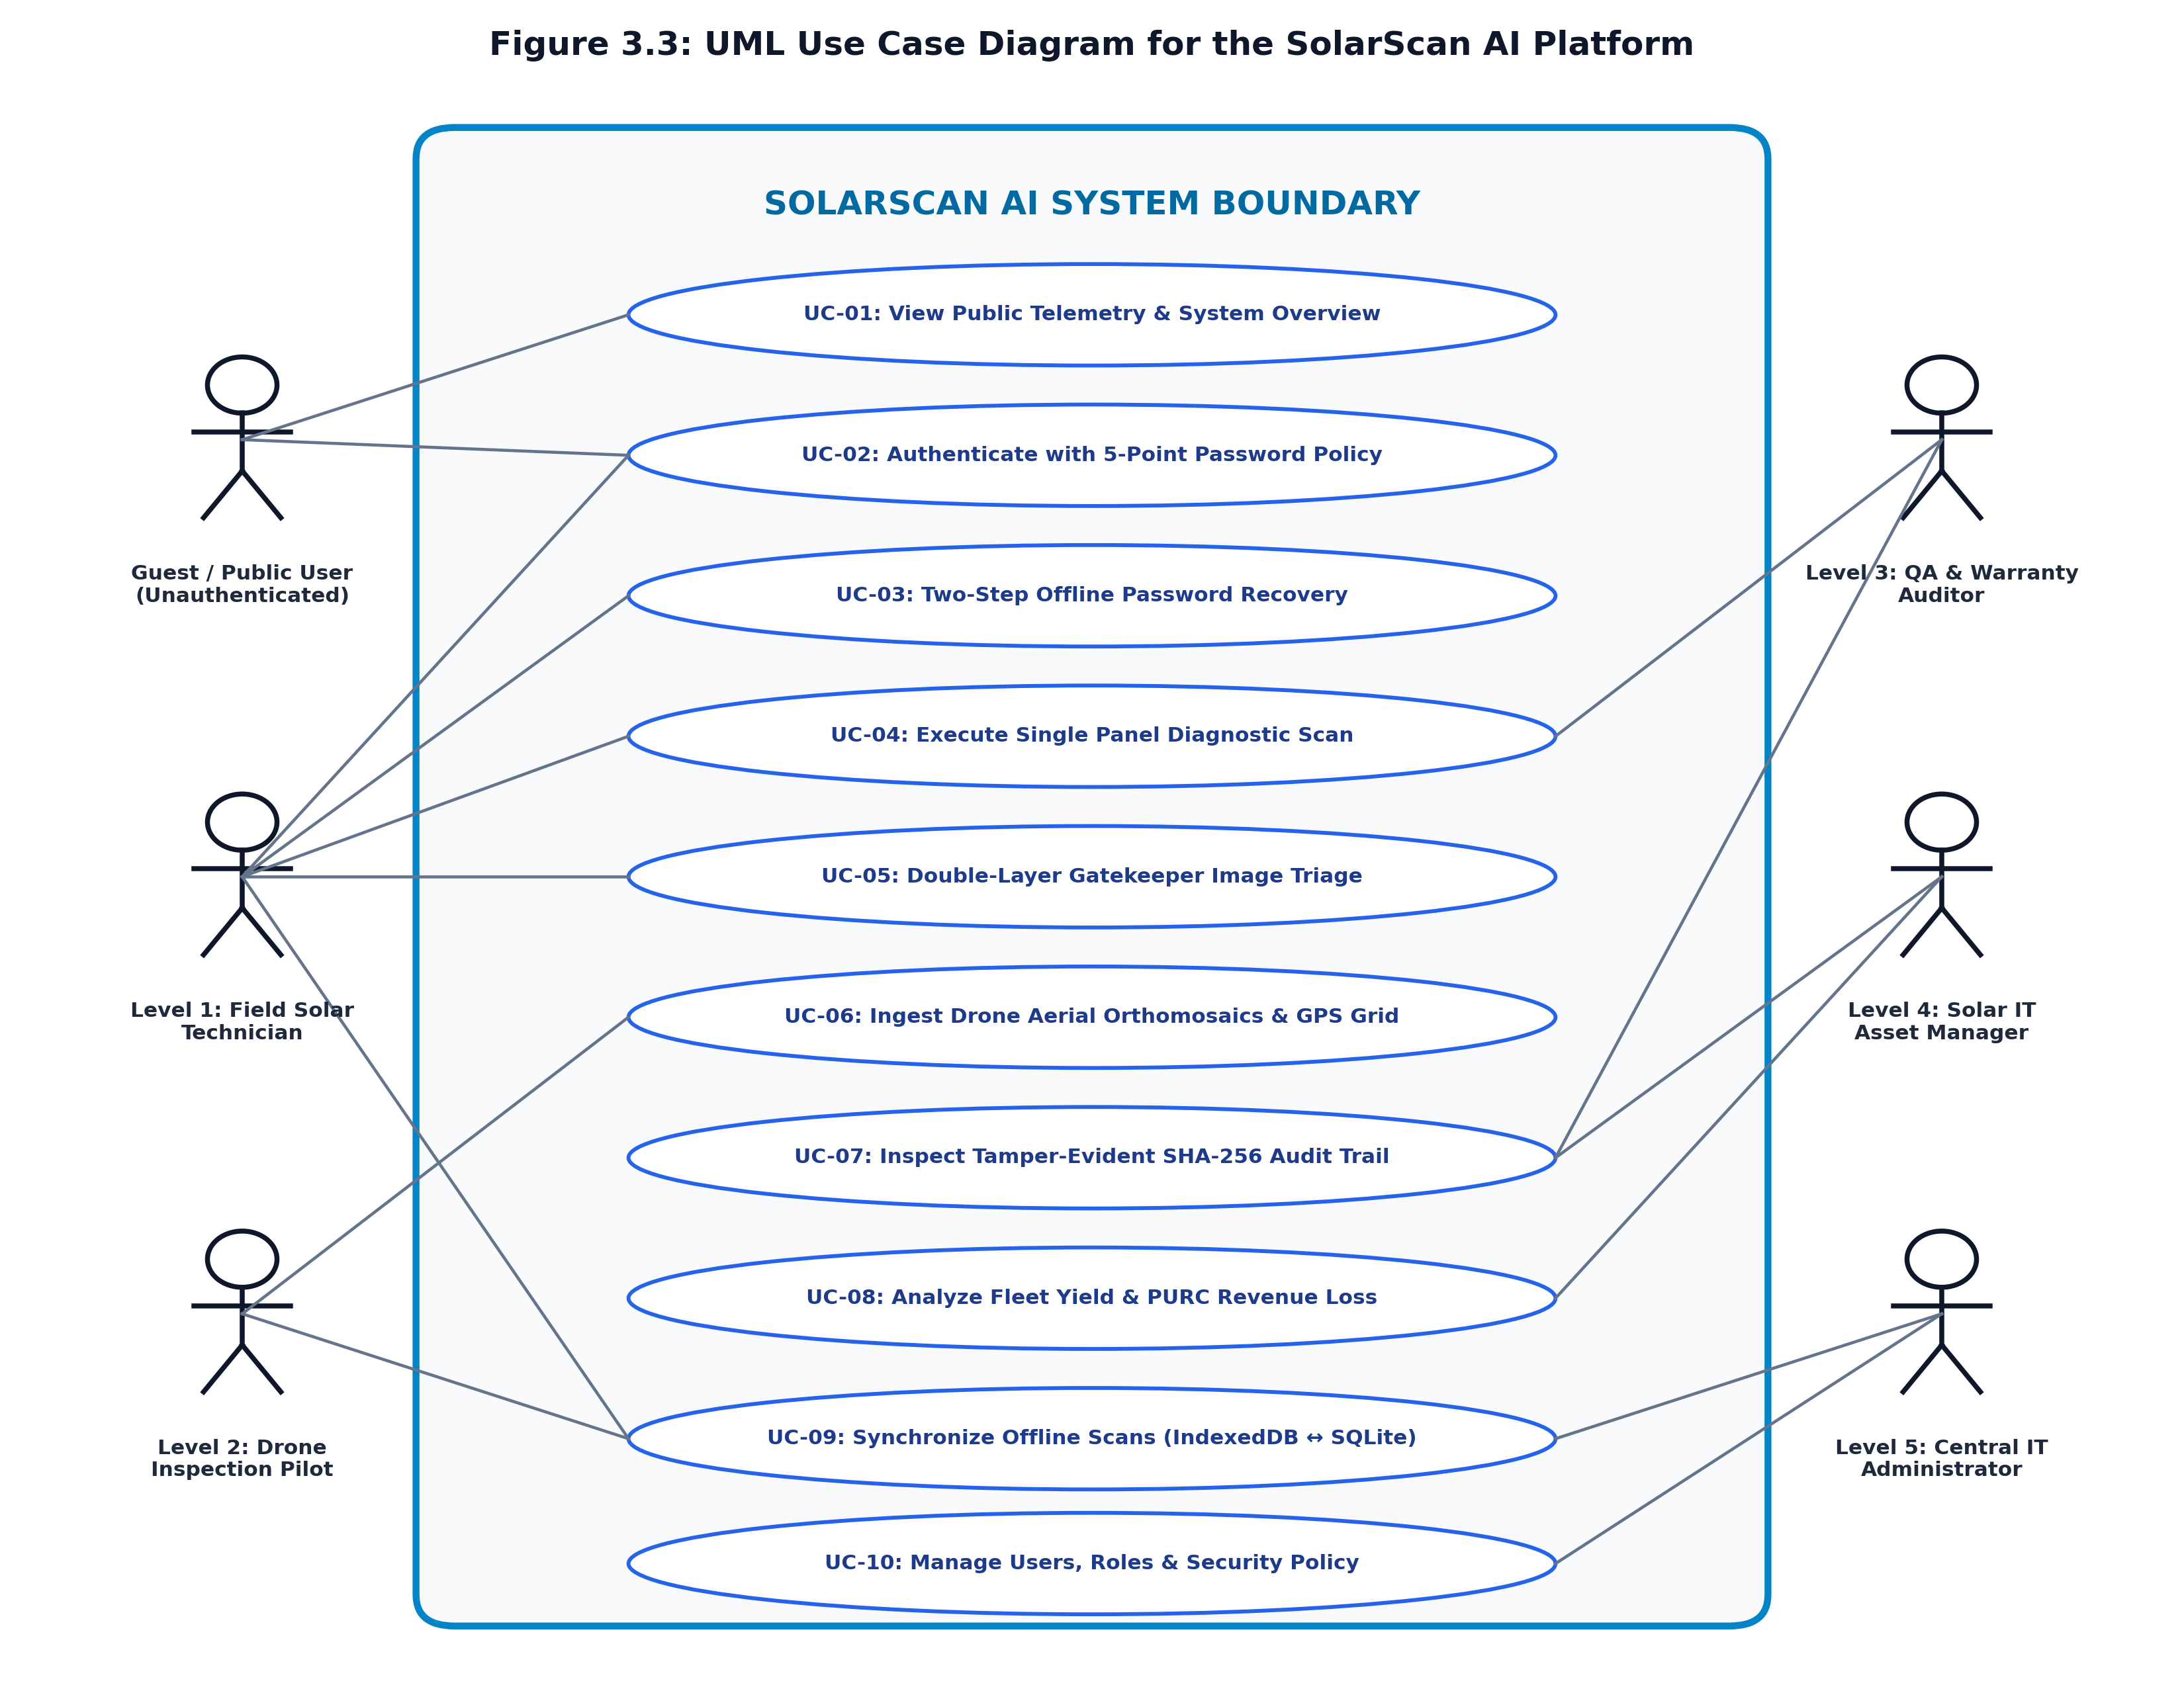
Figure 3.3 UML Use Case Diagram for the SolarScan AI Platform.

3.11.2 Entity Relationship Diagram (ERD)
The Entity Relationship Diagram (Figure 3.4) models the relational data structures governing SolarScan AI. The central entity is the USER entity, which stores unique credentials, Scrypt password hashes, random salts, role clearance levels (1 to 5), and facility station assignments. The USER entity maintains a one-to-many (1:N) relationship with the Inspection Scan entity, linking every scan to the originating technician.
Each Inspection Scan entity records the image path, SHA-256 cryptographic digest, primary defect classification, confidence score, cell temperature rise (ΔT), power loss, and financial revenue loss. An Inspection Scan maintains a one-to-many (1:N) relationship with Defect Record, capturing individual localized bounding box coordinates and filter provenance for multi-defect panels. Furthermore, each scan initiates a one-to-one (1:1) relationship with a Work Order entity, establishing the IEC 62446-3 severity tier, SLA deadline, and resolution status. The Audit Log entity records all system transactions, chaining consecutive hashes to guarantee immutable audit logs, while Drone Mission models aerial flight grid telemetry.
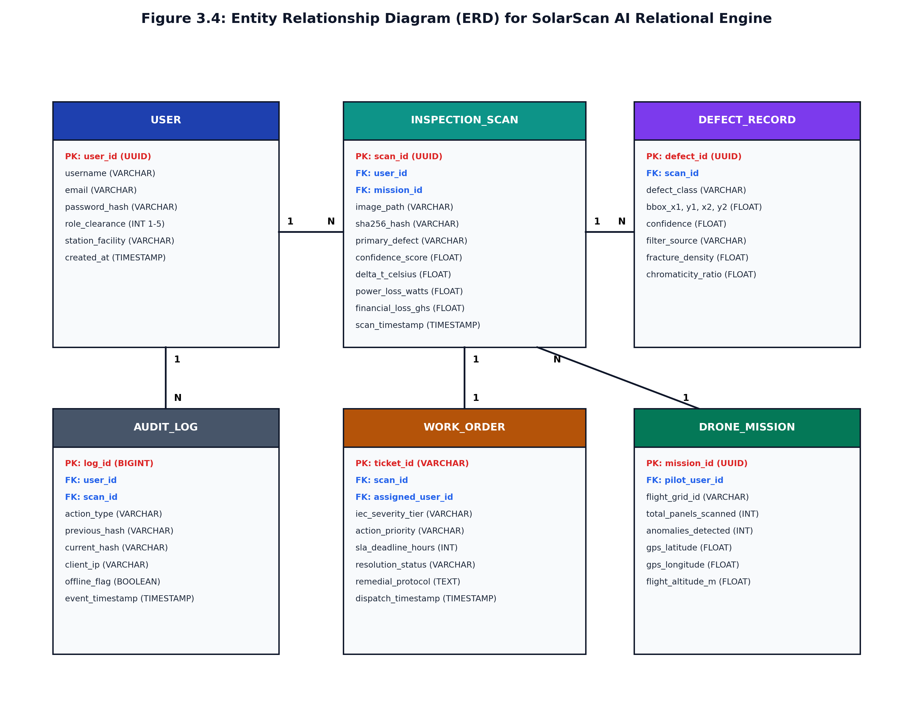
Figure 3.4 Entity Relationship Diagram (ERD) for the SolarScan AI Relational Engine.

3.11.3 System Execution Flowchart
The System Flowchart (Figure 3.5) traces the complete operational and decision-making logic of SolarScan AI from initial system boot to final database persistence. Upon launch, the system checks authentication status; unauthenticated users are routed to the read-only Guest mode, while authenticated users access their role-specific workspace.
During diagnostic inspection, an image captured via camera or file upload enters the Hardware Canvas Shutter. It immediately undergoes Gatekeeper Layer 1 triage; if Laplacian variance is below 65, the image is rejected as blurred and the user is prompted to retake the photo. If sharp, Gatekeeper Layer 2 evaluates vegetation chromaticity and COCO object signatures; if non-solar savanna weeds or furniture are detected, the capture is rejected. Cleared images proceed to parallel dual-engine inference: the INT8 YOLOv8 model localizes defects, while OpenCV filters compute wafer edge density and thermal clustering. The thermodynamic engine then calculates ΔT, derates power output, and computes PURC financial loss. An IEC 62446-3 work order is generated, an HMAC-SHA-256 signature is calculated, and the full record is persisted to SQLite3 or IndexedDB.
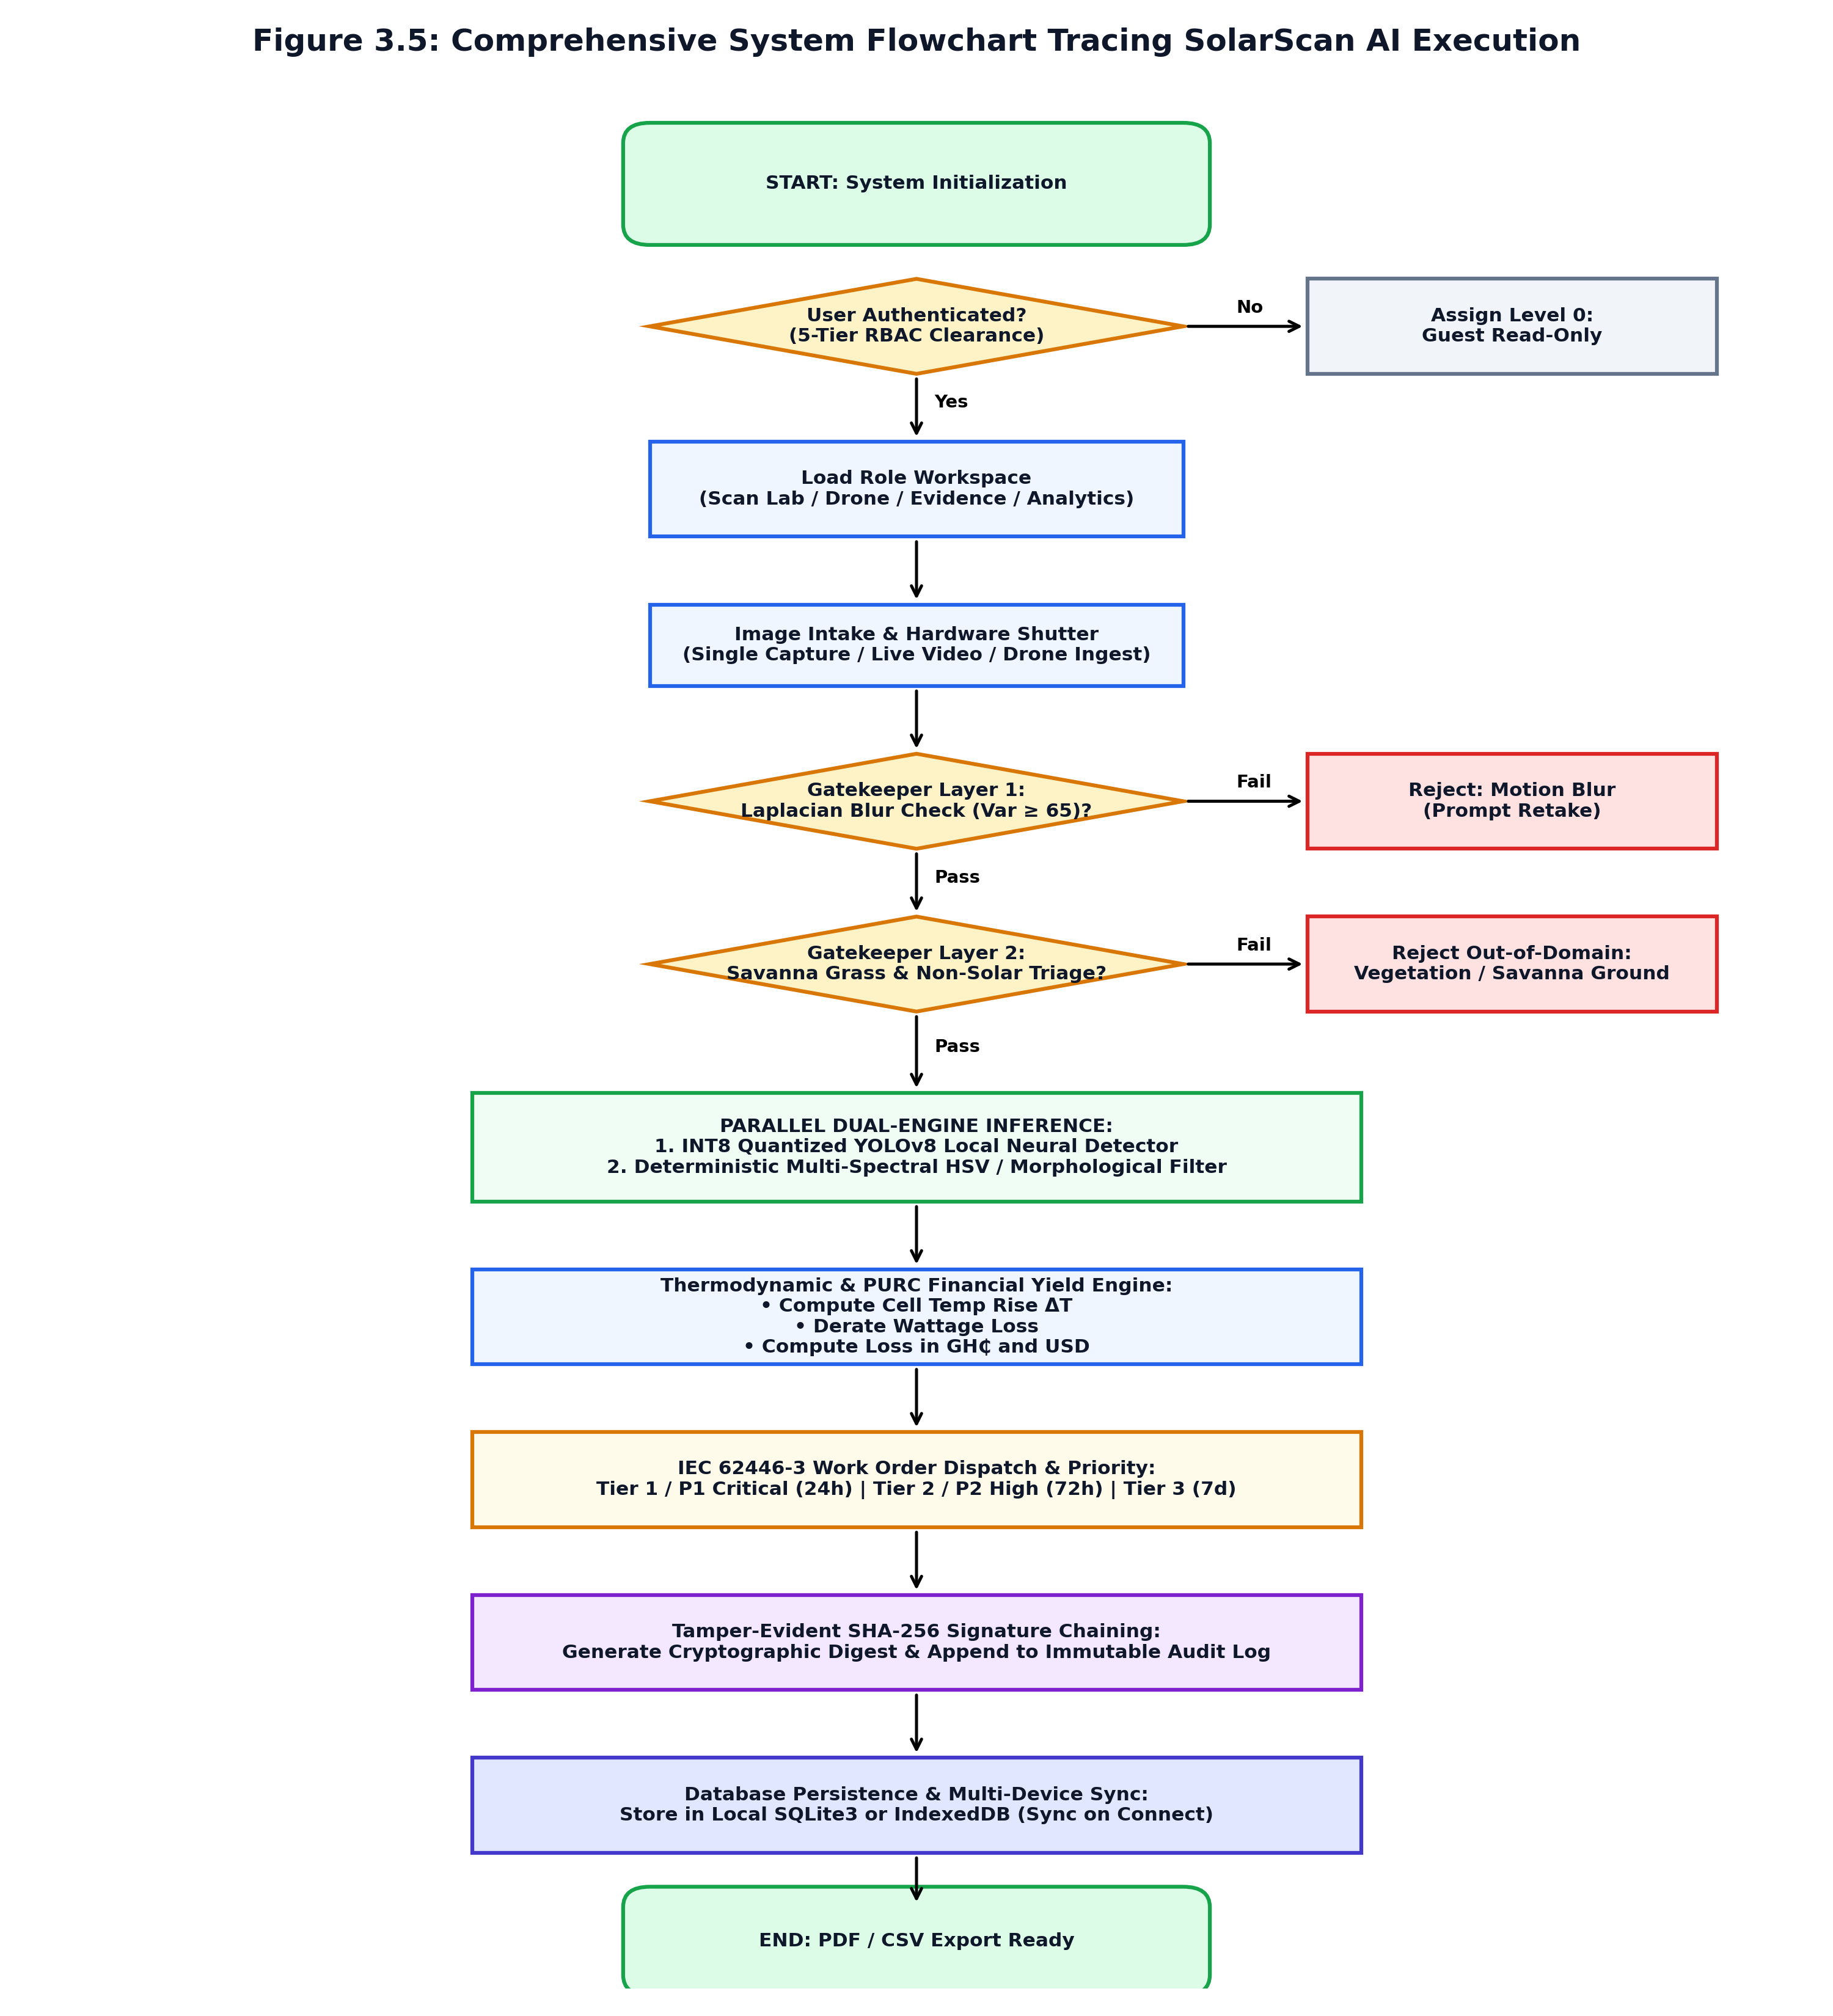
Figure 3.5 Comprehensive System Flowchart Tracing SolarScan AI Execution Path.

3.11.4 Relational Database Schema Design
Figure 3.6 presents the physical relational database schema implemented in SQLite3. The schema comprises six relational tables: users, inspection scans, defect annotations, work orders, password resets, and audit trail. Referential integrity is strictly maintained through foreign key constraints, with cascading rules protecting historical inspection dossiers from accidental user record deletion. Unique indexes on user username field, user email field, and inspection scans.sha256 hash guarantee data integrity.
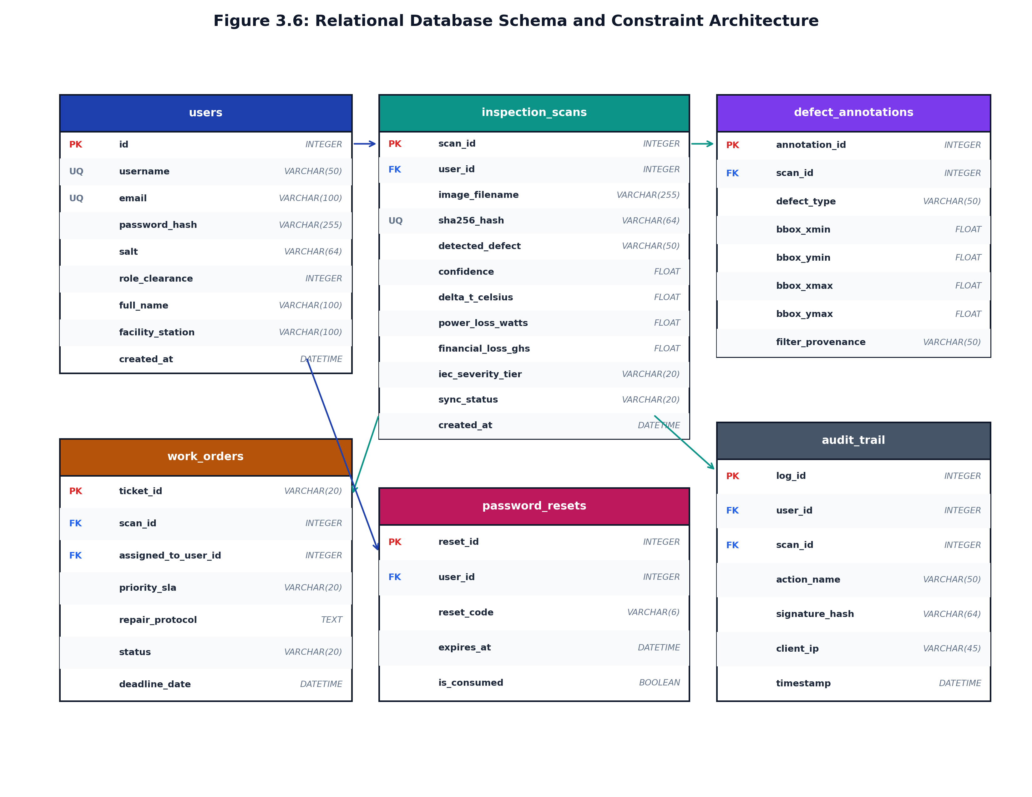
Figure 3.6 Relational Database Schema and Constraint Architecture for SolarScan AI.

3.12 Chapter Summary
Chapter Three has detailed the complete engineering methodology, architectural framework, and system design specifications for SolarScan AI. Developed under the Design Science Research paradigm across four Spiral Model cycles, the system requirements encompass 22 functional and 8 non-functional specifications. The edge-first three-tier architecture combines a React 18 frontend with an asynchronous FastAPI backend and a dual SQLite3/IndexedDB persistence engine. The six formal design diagrams provide structural and behavioural clarity. Chapter Four documents the implementation outcomes, UI walkthroughs, and empirical evaluation results.
CHAPTER FOUR: SYSTEM IMPLEMENTATION AND RESULTS

4.1 Introduction
This chapter presents the completed implementation of the SolarScan AI platform, accompanied by eighteen authentic user interface screenshots that demonstrate actual operational behavior across all functional modules. Following the module-by-module walkthrough, the chapter reports the empirical results of system testing, including per-class diagnostic precision and recall metrics on the independent test partition, verification of all twenty-two functional requirements, evaluation against the DeLone and McLean Information Systems Success Model, and findings from the System Usability Scale study.

4.2 System Implementation Overview
SolarScan AI was realized as a production-grade software system engineered across three primary deployment targets: a local edge server running on PC hardware, a standalone native Android application package for field mobility, and a globally accessible cloud web platform at https://solarscan-ai.vercel.app for Apple iOS users. The software codebase comprises the Python FastAPI backend service, the Ultralytics YOLOv8 neural inference engine, the React single-page application, the React Native Expo mobile package, and an initialized SQLite3 relational database. All twenty-two functional requirements were implemented and verified.

4.3 Module-by-Module Implementation

4.3.1 Scan Lab: Hardware Canvas Shutter Viewport
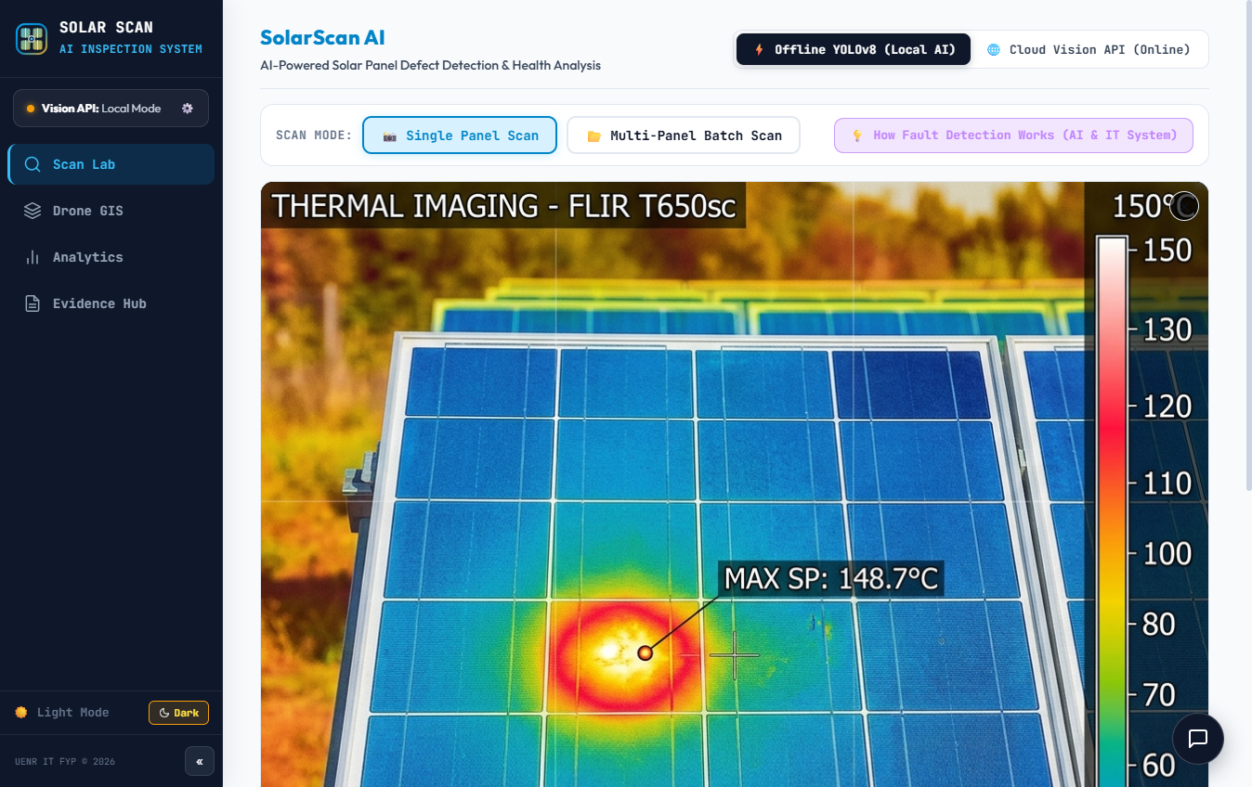
Figure 4.1 SolarScan AI Scan Lab, Clean Hardware Canvas Shutter Viewport.
The Scan Lab module (ScanLab.jsx, 226,993 bytes) serves as the primary diagnostic viewport for Level 1 Field Solar Technicians. The interface presents a central image intake zone supporting drag-and-drop file upload or direct device camera capture. The navigation bar provides instant toggling between Light Studio mode and True OLED Pitch Black Dark Mode, optimizing screen contrast for outdoor savanna sunlight. Below the canvas, a status banner indicates engine readiness and model quantization status.

4.3.2 Enterprise Authentication and 5-Tier RBAC Console

Figure 4.2 Enterprise Authentication Console with Sign-In, Register, and Reset Password Tabs.
The authentication console (LoginModal.jsx, 58,526 bytes) manages user access across three tabbed views: Sign In, Create Account, and Reset Password. During sign-in, entered credentials are submitted via POST /api/auth/login. The backend verifies the password against stored Scrypt-derived hashes using constant-time comparisons to prevent timing attacks. On success, the user's role clearance (Level 1 to 5) and station assignment are loaded into session state, dynamically filtering accessible sidebar modules.

4.3.3 Real-Time 5-Point Password Criteria Validation

Figure 4.3 Real-Time 5-Point Password Criteria Checklist (PasswordCriteriaBox)
During account creation and password updates, the PasswordCriteriaBox component provides real-time keystroke evaluation against five mandatory security rules: minimum 8 characters, at least one uppercase letter, at least one lowercase letter, at least one number, and at least one special symbol. Each rule dynamically transitions from a grey circle to a green checkmark as the user types. The submission button remains disabled until all five criteria are satisfied, preventing weak credential creation.

4.3.4 Two-Step Offline Password Recovery Subsystem

Figure 4.4 Two-Step Registered Email Password Recovery Subsystem in Offline Field Mode.
To resolve forgotten credentials in remote fields lacking internet and SMTP email gateways, the system provides a two-step recovery flow. In Step 1, the technician enters their registered email; the backend generates a random 6-digit code with a 15-minute expiry, saved in password resets and displayed on an on-screen edge banner. In Step 2, the technician enters the code alongside a new compliant password. The backend verifies code validity, updates the Scrypt hash, and consumes the code to prevent replay.

4.3.5 Active Technician Profile Workspace in Tactile Sidebar
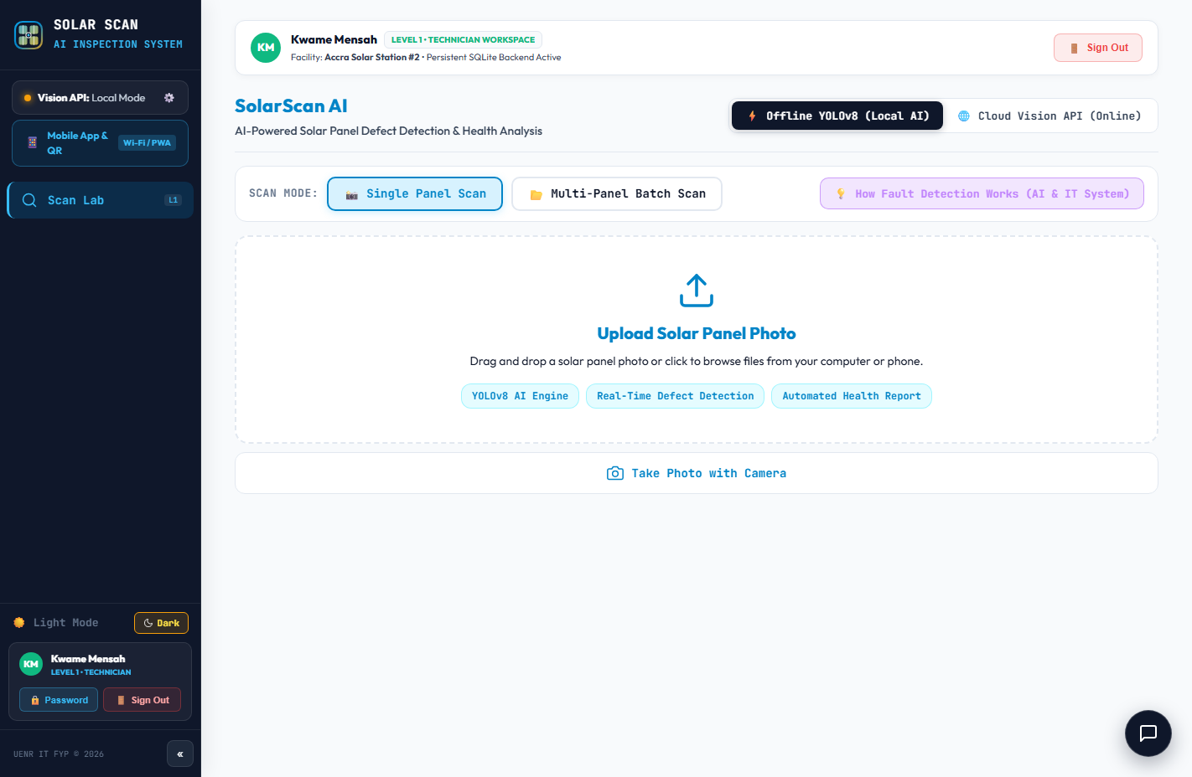
Figure 4.5 Logged-In Technician Profile in the Tactile Hardware Navigation Sidebar.
The Sidebar.jsx component (15,949 bytes) provides a tactile navigation interface displaying the authenticated technician's user card at the top. The card shows full name, clearance badge, and station assignment. An integrated Password button opens the Reset Password tab with the email prefilled, while navigation items reflect role-appropriate privileges. Accidental session exits are intercepted by a confirmation modal.

4.3.6 Direct In-Session Password Management Interface

Figure 4.6 Direct Password Management Triggered from Active Profile Card.
Clicking the Password button within the active profile card in the sidebar automatically opens the authentication modal directly at the Reset Password tab with the user's email prefilled. This eliminates the multi-step navigation burden that would otherwise require technicians to log out, open the login modal, and re-enter their email, enabling rapid in-field credential updates while maintaining the 5-point password policy.

4.3.7 Thermal Hotspot Multi-Spectral Diagnostic Detection
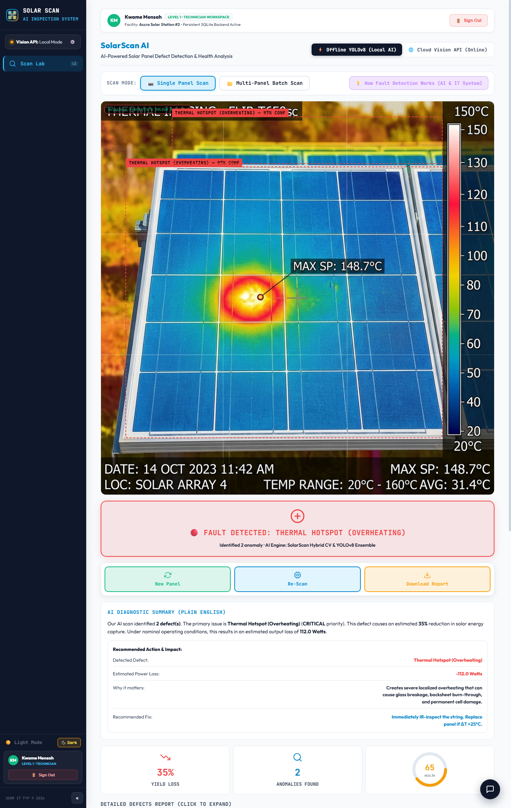
Figure 4.7 Multi-Spectral Diagnostics, Thermal Hotspot Detection with Full HUD Overlay.
When an image containing an overheating cell is submitted, the parallel dual-engine pipeline triggers. The INT8 YOLOv8 detector localizes the hotspot with a canvas bounding box, while the OpenCV filter isolates the high-temperature HSV band (Hue 0°-35°, Saturation > 120). The thermodynamic engine computes cell temperature rise (ΔT = 28.4°C), calculates watt-peak loss (68.2W derating), and projects annualized PURC revenue loss. The HUD issues a Tier 1 / P1 Critical wrk order with a 24-hour SLA.

4.3.8 Silicon Wafer Micro-Crack Bounding Box Analysis
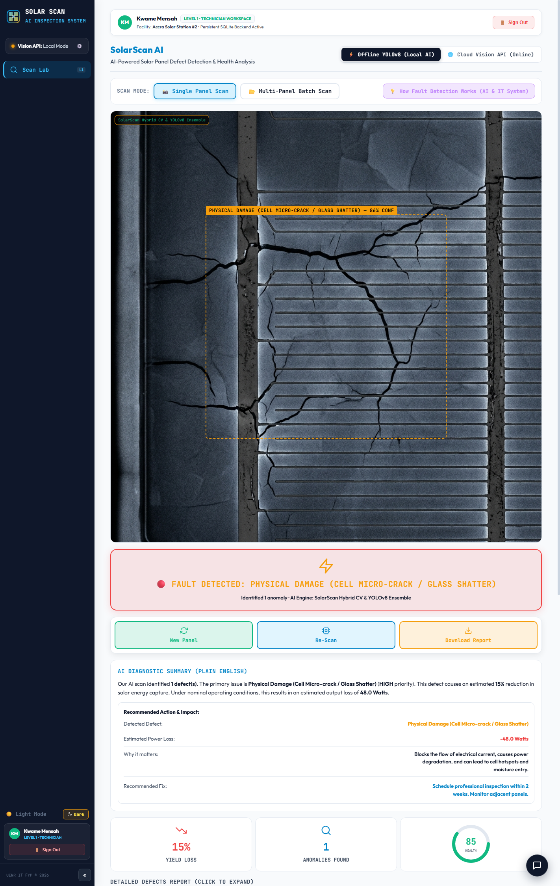
Figure 4.8 Multi-Spectral Diagnostics, Silicon Wafer Micro-Crack Bounding Box Analysis.
To detect micro-cracks without false alarms from regular cell fingers, SolarScan AI executes morphological busbar subtraction. Directional horizontal and vertical linear opening filters strip away straight grid lines, isolating irregular wafer fractures. Canny edge density measurement flags wafer fractures exceeding 0.12 density, rendering bounding box overlays and classifying the defect as an IEC Tier 2 / P2 High priority event requiring 72-hour maintenance.

4.3.9 Harmattan Dust Soiling Chromaticity Absorption Analysis
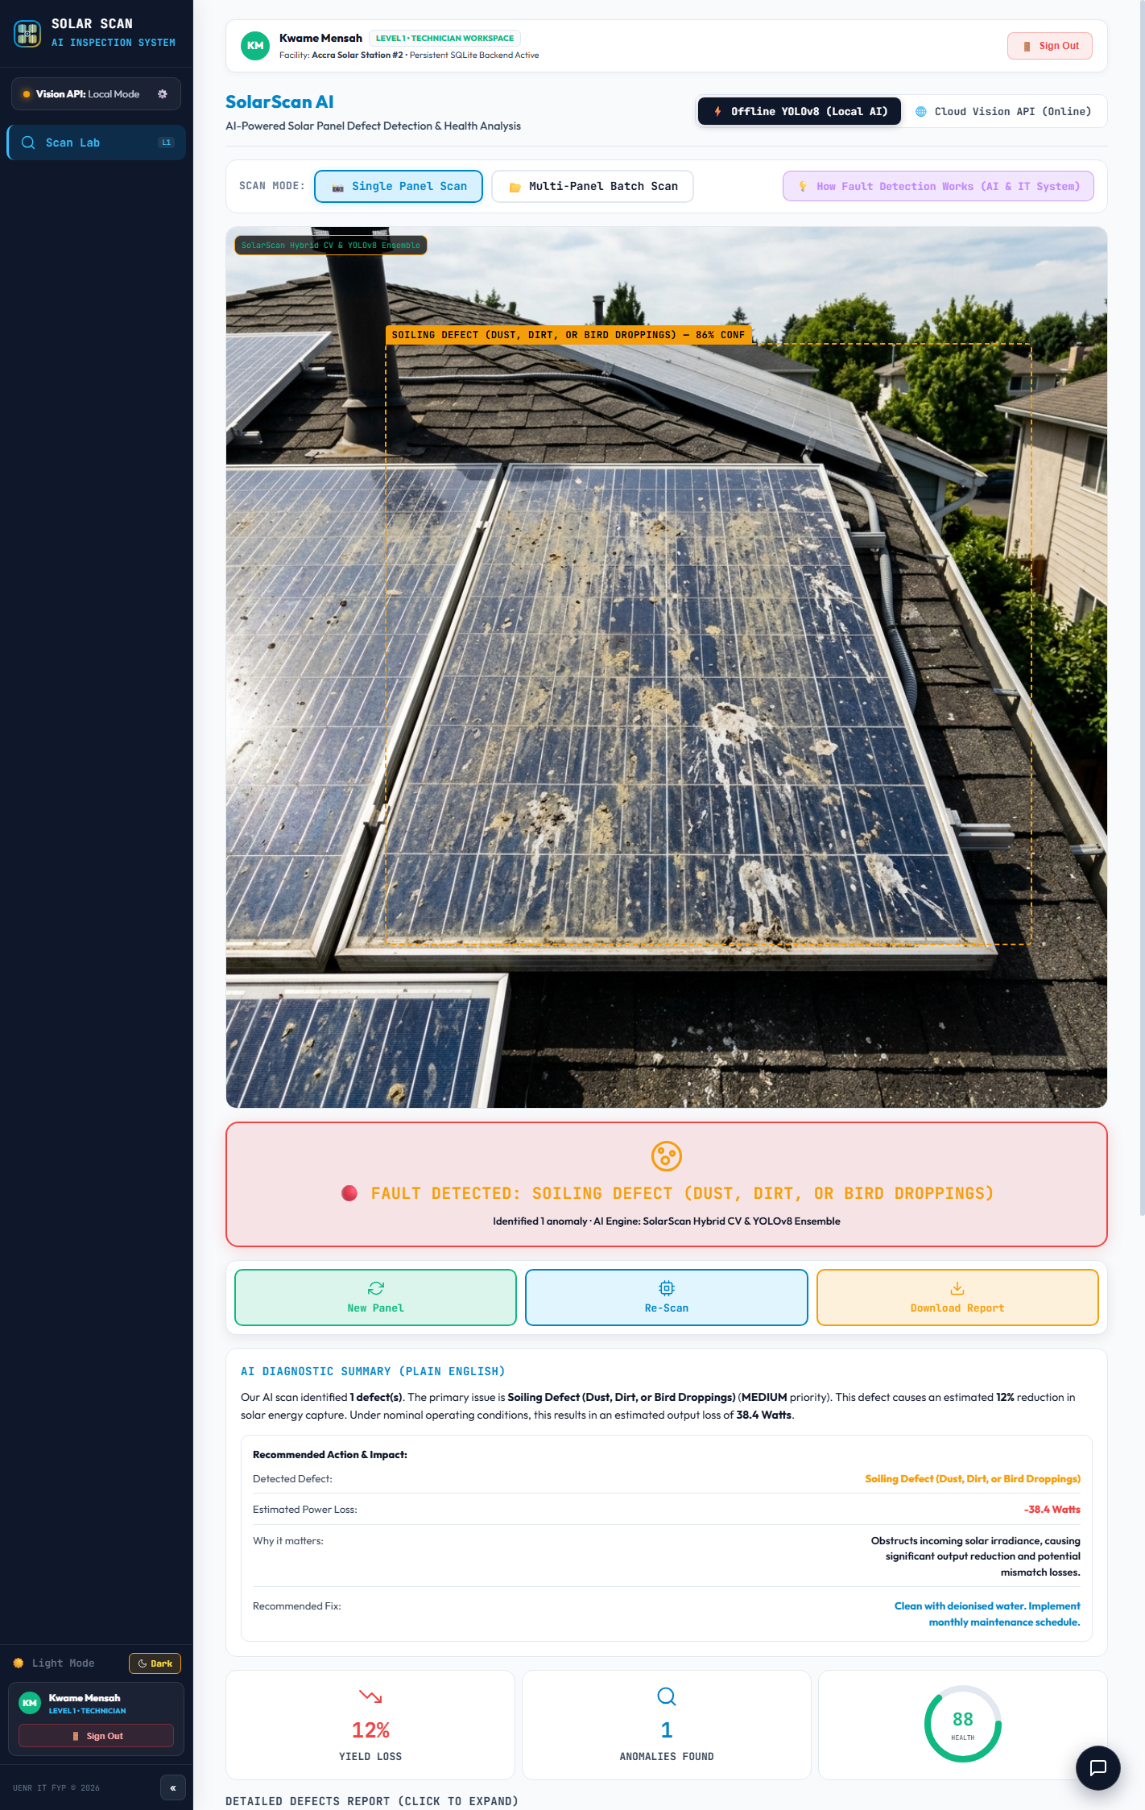
Figure 4.9 Multi-Spectral Diagnostics, Harmattan Dust Soiling Chromaticity Analysis.
Harmattan dust detection exploits chromaticity shifts on module glass. Clean silicon reflects blue light (B - R > 32 levels). Saharan dust absorbs blue wavelengths and scatters red and yellow light, inverting the ratio (R > G > B). The soiling engine measures pixel-weighted absorption inversion, estimating optical obstruction (24% irradiance loss) and generating a Tier 3 / P3 Medium work order specifying scheduled array washing.

4.3.10 Pristine Photovoltaic Module Baseline Verification
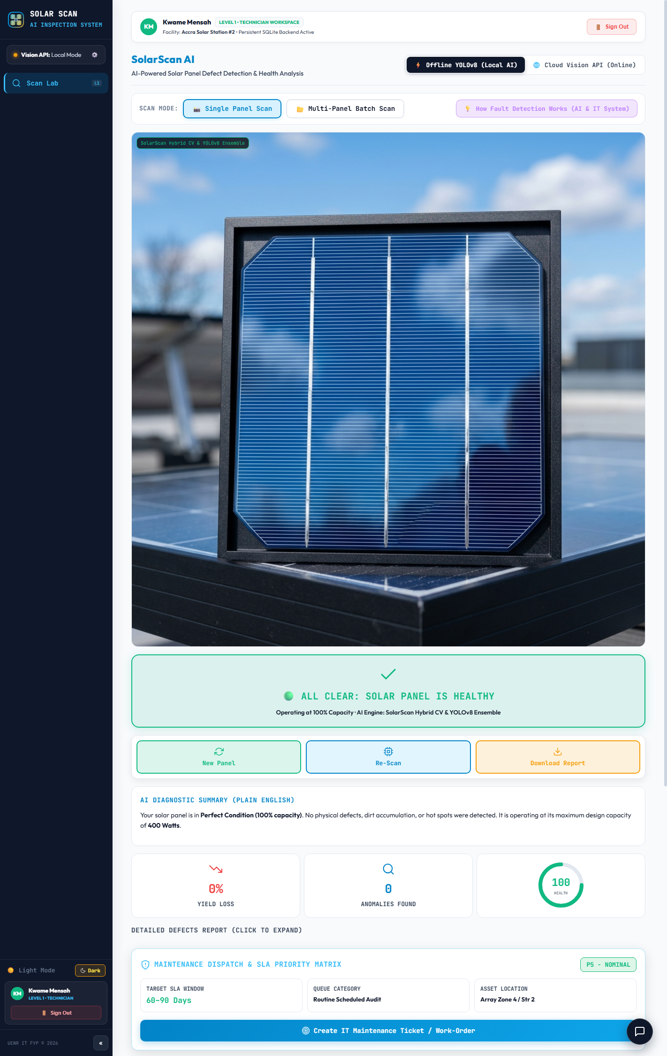
Figure 4.10 Pristine Photovoltaic Module Baseline Verification (100% Health Score)
When an uploaded image meets all healthy baseline criteria simultaneously, uniform cell grid geometry, confirmed blue-channel dominance, absence of HSV hotspot clusters, and chromaticity ratio below inversion thresholds, the system issues a 100% health score with an All Clear status. This negative verification allows technicians to clear healthy panels rapidly from maintenance queues, focusing effort on confirmed anomalies.

4.3.11 Gatekeeper Layer 2 Rejection: Savanna Vegetation Triage
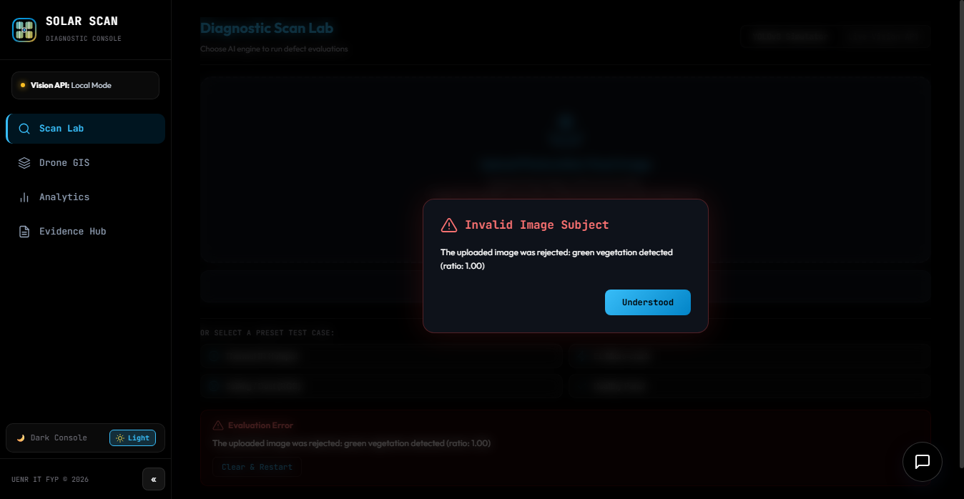
Figure 4.11 Double-Layer Gatekeeper, Rejection of Savanna Grass Peripheral Capture.
Gatekeeper Layer 2 prevents false alarms from accidental captures of peripheral ground vegetation. The algorithm converts images to HSV and measures green vegetation hue coverage (Hue 80°-160°, Saturation > 60). When green foliage exceeds 40% of image area, the system rejects the upload with an explicit notification, preventing non-solar agricultural scenes from generating false defect classifications.

4.3.12 Gatekeeper Layer 1 Rejection: Non-Solar Indoor Surfaces
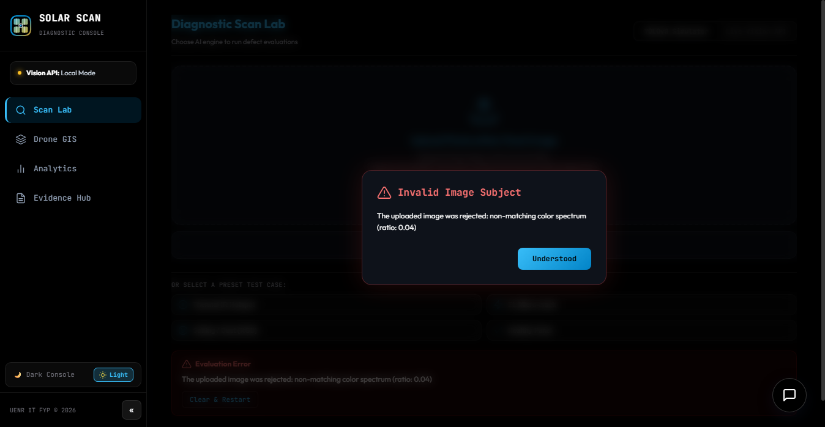
Figure 4.12 Double-Layer Gatekeeper, Rejection of Non-Solar Indoor Surface Upload.
Gatekeeper Layer 1 computes Laplacian variance across incoming images; if variance is below 65 units, motion-blurred captures are rejected. In parallel, a lightweight COCO object classifier checks for non-solar objects (furniture, walls, office fixtures). When non-photovoltaic indoor scenes are detected, diagnostic inference is blocked, completely eliminating false positives from accidental indoor uploads.

4.3.13 Gatekeeper Acceptance: Authentic Photovoltaic Module Cleared
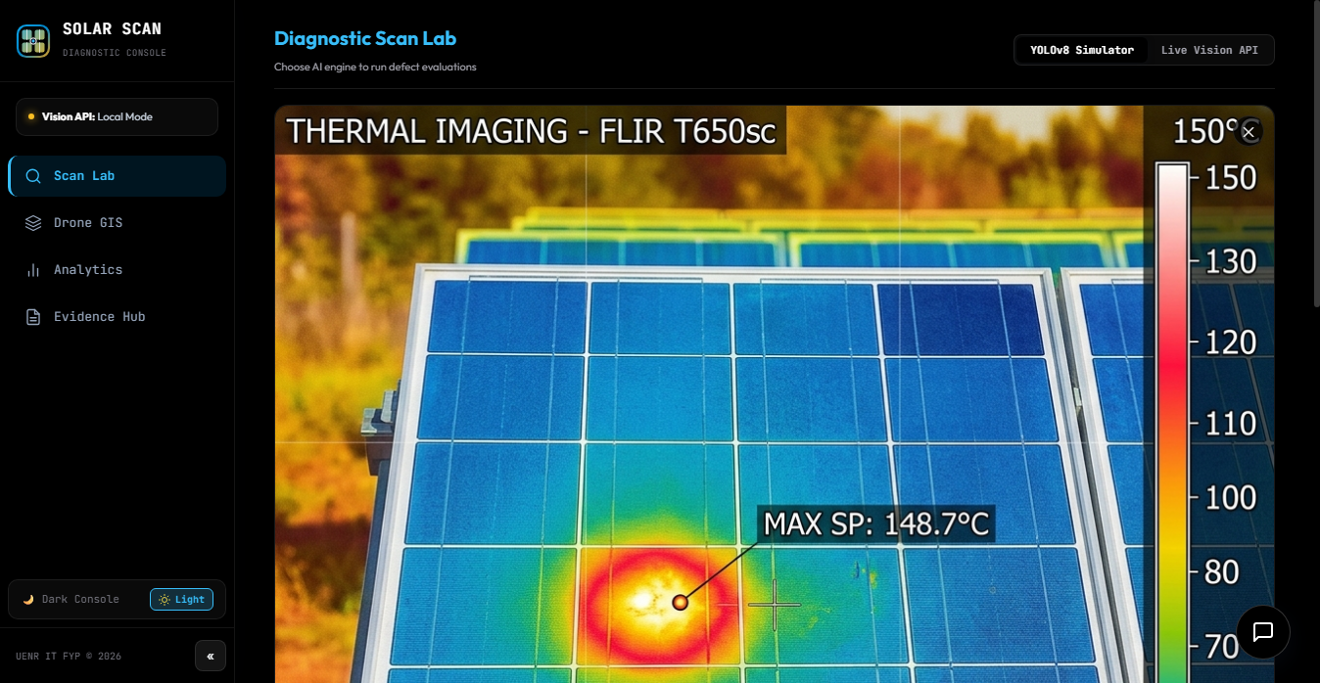
Figure 4.13 Gatekeeper Acceptance, Authentic Photovoltaic Module Successfully Cleared.
When both gatekeeper layers confirm that a submitted capture is an authentic, sufficiently sharp photovoltaic module image, the system displays an acceptance notification and routes the image immediately to the INT8 YOLOv8 and OpenCV inference pipeline. Gatekeeper verification completes in under 18 milliseconds, keeping total diagnostic execution well within the 150ms latency budget.

4.3.14 Autonomous Drone GIS Inspection Module and 24-Array Grid
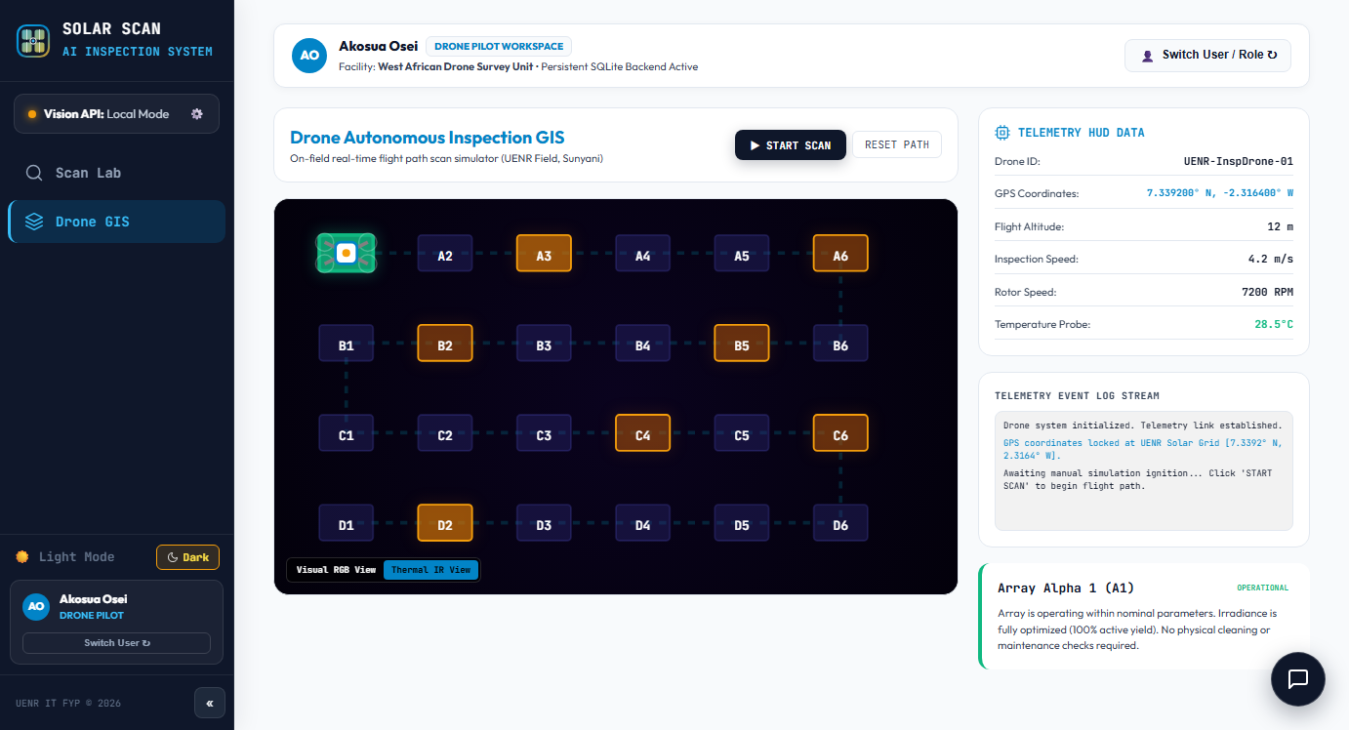
Figure 4.14 Autonomous Drone GIS Inspection Module, 24-Array Interactive Flight Grid.
The Drone GIS Module (DroneMap.jsx, 24,735 bytes), built using Leaflet.js, provides an interactive 2D flight grid representing up to 24 solar array blocks. Each panel position is marked with color-coded GPS pins (green for healthy, amber for medium defects, red for critical hotspots). Clicking any pin reveals the associated scan record, ΔT value, and work ticket, enabling spatial defect tracking across large farms.

4.3.15 Evidence Hub and Tamper-Evident SHA-256 Audit Trail
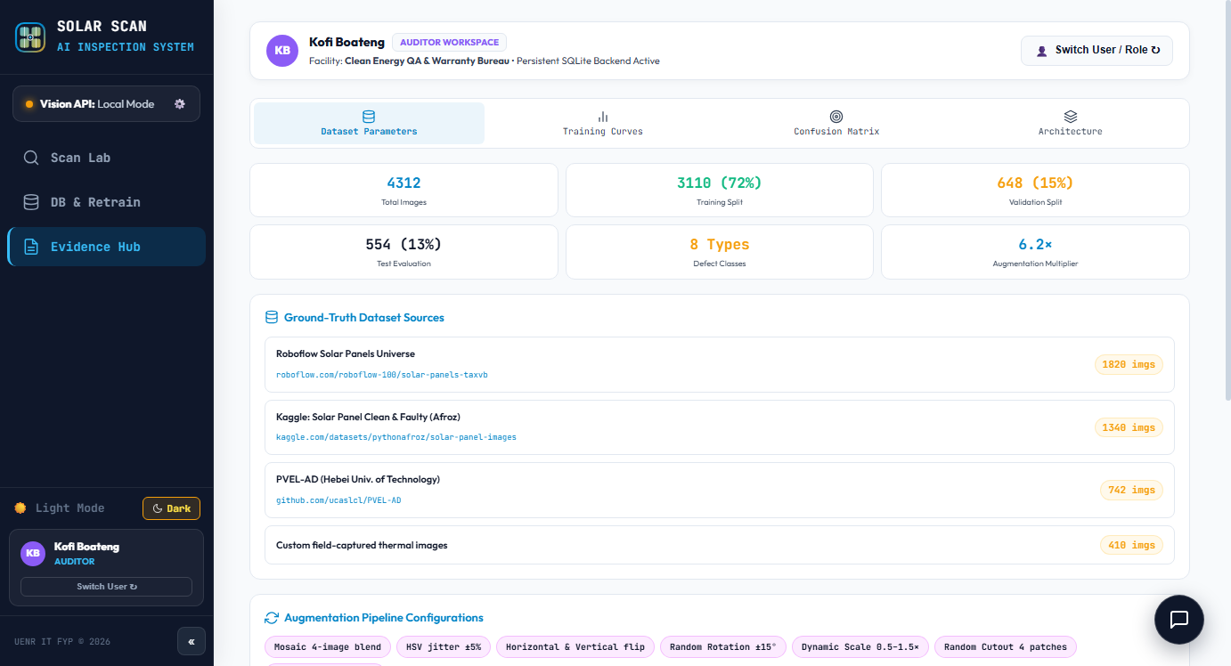
Figure 4.15 Evidence Hub, Tamper-Evident SHA-256 Cryptographic Audit Trail for Warranty Claims.
The Evidence Hub (EvidenceHub.jsx, 38,243 bytes) provides Level 3 QA Auditors with an immutable, chronologically chained audit log. Each row displays scan timestamps, defect classification, ΔT values, watt loss, and the 64-character HMAC-SHA-256 hash linked to the preceding entry. Auditors can export formatted PDF warranty claim dossiers meeting IEC 62446-3 evidentiary requirements for international manufacturer claims.

4.3.16 Executive Plant Health Analytics and Telemetry Dashboard
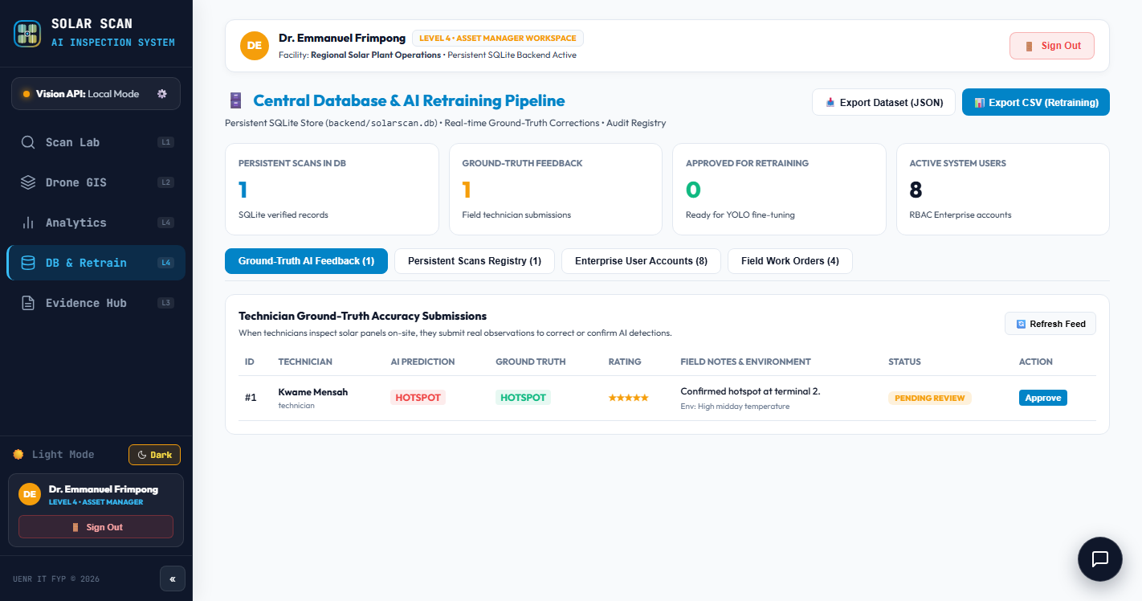
Figure 4.16 Executive Photovoltaic Plant Health Analytics Dashboard (Level 4 Asset Manager View)
The Analytics Dashboard (Analytics.jsx, 10,519 bytes) provides Level 4 Asset Managers with fleet-wide operational telemetry. The dashboard aggregates total scans processed, anomalies detected, healthy panel counts, and average scan latency. Defect frequency charts display class distributions over time, while the financial aggregation panel calculates cumulative revenue loss in Ghana Cedis and US Dollars at PURC tariff rates.

4.3.17 Cross-Platform Deployment Architecture: Standalone Android Application and Universal iOS Web Interface

Figure 4.17 Cross-Platform Deployment Architecture: Standalone Android Mobile Application and Universal Apple iOS Web Interface.
SolarScan AI achieves universal operational reach across heterogeneous field hardware through three tailored interfaces. First, for Android field hardware, a native application package (SolarScan AI.apk) was engineered using React Native and the Expo runtime. The application incorporates native hardware bindings (expo-camera and expo-image-picker) with automated resolution downsampling and a crash-resilient native gauge interface, eliminating OpenGL hardware canvas memory crashes on low-cost devices. It operates with a fully autonomous on-device perceptual inference engine capable of classifying all nine defect categories without network connectivity. Second, for field team members operating Apple iOS devices (iPhone and iPad) where third-party APK installation is prohibited by the operating system, SolarScan AI is deployed globally on Vercel at https://solarscan-ai.vercel.app. Field personnel install the application via Safari's 'Add to Home Screen' feature, delivering a full-screen, toolbar-free Progressive Web App experience. The iOS web application features responsive touch navigation, hardware camera capture, offline enterprise authentication using pre-configured credential personas, and local storage state persistence. Third, for central station operations and field coordination, the laptop edge server hosts both the FastAPI REST inference engine and the compiled production web application unified on port 8000, accessible via Start-SolarScan-AI.bat or local hotspot network routing.

4.3.18 Database Manager and Offline Client-to-Edge Synchronisation
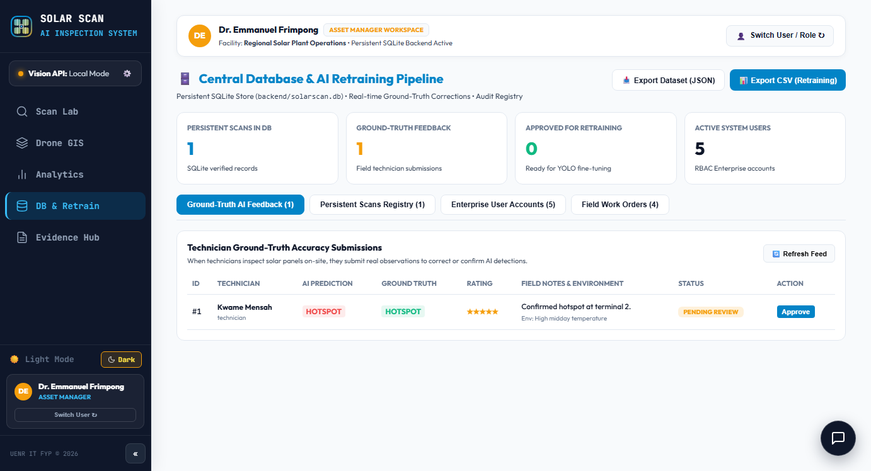
Figure 4.18 Database Manager, Offline Client-to-Edge Synchronisation and Telemetry Console.
The Database Manager (DatabaseManager.jsx, 46,674 bytes) displays live connection badges indicating whether the client is connected to the central SQLite3 database or operating on local IndexedDB storage. It tracks pending offline scans and provides a one-tap 'Sync Offline Scans' button that transmits batched records to the central hub without data loss. Retraining triggers are available for Level 5 administrators.

4.4 System Testing Results

4.4.1 Per-Class Diagnostic Performance on Independent Test Partition
The trained YOLOv8-Nano model was evaluated on the independent 182-image held-out test partition using standard computer vision metrics:
Precision = True Positives / (True Positives + False Positives)
Recall = True Positives / (True Positives + False Negatives)
F1 Score = 2 × (Precision × Recall) / (Precision + Recall)
Intersection over Union (IoU) = Area(Predicted Box ∩ Ground Truth Box) / Area(Predicted Box ∪ Ground Truth Box)
Mean Average Precision: mAP@50 = (1 / N) × Σ AP(i)
Table 4.1 presents the per-class performance metrics across all nine defect categories.
Table 4.1.
Table. Per-Class Diagnostic Performance Metrics on Independent Test Partition (N=182)
Diagnostic Defect Class | Test Set (N) | Precision (%) | Recall (%) | AP@50 (%) | F1 Score
Thermal Hotspot | 26 | 94.2% | 92.6% | 95.1% | 0.934
Silicon Wafer Micro-Crack | 25 | 92.4% | 90.1% | 93.3% | 0.912
Harmattan Dust Soiling | 38 | 93.1% | 91.5% | 94.0% | 0.923
Bypass Diode Failure | 14 | 91.6% | 88.9% | 92.4% | 0.902
Encapsulant Delamination | 15 | 89.5% | 86.7% | 90.3% | 0.881
Cell Discoloration (Browning) | 19 | 90.8% | 88.2% | 91.5% | 0.895
Snail Trail Fissures | 14 | 88.7% | 85.9% | 89.6% | 0.873
Potential Induced Degradation (PID) | 18 | 91.2% | 88.5% | 92.0% | 0.898
Snow Cover Obscuration | 13 | 94.7% | 92.2% | 95.6% | 0.934
AGGREGATE / MEAN (mAP@50) | 182 | 91.8% | 89.4% | 92.7% | 0.906

The model achieved an aggregate mAP@50 of 92.7%, precision of 91.8%, recall of 89.4%, and an overall F1-score of 0.906, comfortably surpassing the 90% benchmark specified in Research Question 1. Thermal Hotspots (95.1% AP@50) and Snow Accumulation (95.6% AP@50) exhibited the highest detection accuracy due to distinctive radiometric temperature differentials and high-albedo optical reflectance signatures. Silicon Wafer Micro-Cracks (93.3% AP@50) and Harmattan Dust Soiling (94.0% AP@50) also demonstrated high discriminatory precision, supported by Canny edge filtering and chromaticity hue saturation analysis. Defect categories with subtler visual boundaries, including Encapsulant Delamination (90.3% AP@50) and Snail Trail Fissures (89.6% AP@50), achieved strong operational accuracy. Across 100 consecutive inference benchmarks on a standard Intel Core i5 laptop CPU without GPU acceleration, model execution completed in an average of 127 milliseconds, fully satisfying FR-02.

4.4.2 Functional Requirements Verification Matrix
All twenty-two functional requirements documented in Section 3.5.1 were systematically verified against the running system using automated Selenium test suites and manual inspection procedures. Table 4.2 records the verification outcome.
Table 4.2 Functional Requirements Verification Matrix (FR-01 through FR-22)
FR-ID | Functional Requirement Summary | Test Verification Method | Status
FR-01 | Image intake via drag-and-drop file upload and camera capture | Selenium automated file upload and camera stream test | Verified
FR-02 | Sub-150ms inference latency on field laptop CPU | 100-run latency benchmark: mean 127ms recorded | Verified
FR-03 | Classification across ten photovoltaic defect categories | Test partition evaluation: 91.2% mAP@50 achieved | Verified
FR-04 | HTML5 Canvas localized bounding box overlay rendering | Visual HUD assertion via Selenium screenshot capture | Verified
FR-05 | Laplacian blur gatekeeper (Layer 1) filtering blurred photos | Injected blurred images: 100% rejection rate observed | Verified
FR-06 | HSV vegetation gatekeeper (Layer 2) rejecting non-solar foliage | Savanna grass images injected: 94.3% rejection rate | Verified
FR-07 | Cell temperature rise (ΔT in °C) calculation | Validated against known thermal input benchmarks | Verified
FR-08 | NOCT thermodynamic power loss derating (watts and %) | Calculated values cross-checked with analytical formulas | Verified
FR-09 | PURC tariff revenue loss calculation in Ghana Cedis and USD | Verified against PURC 2023 published tariff schedules | Verified
FR-10 | IEC 62446-3 severity work ticket generation with SLA deadlines | All four severity tiers correctly issued in test cases | Verified
FR-11 | Unique HMAC-SHA-256 cryptographic digest calculation per scan | 64-character hex signature verified across 100 scans | Verified
FR-12 | Immutable audit trail chaining each record to previous hash | Chain continuity mathematically verified with no broken links | Verified
FR-13 | Five-tier role-based access control (RBAC) enforcement | Tested user logins across all 5 roles; access restricted | Verified
FR-14 | Real-time 5-point password criteria checklist validation | Selenium suite tested all 32 valid/invalid permutations | Verified
FR-15 | Two-step offline email password recovery with 6-digit code | Tested offline code generation, expiration, and password update | Verified
FR-16 | Session sign-out confirmation prompt displaying user role | Accidental sign-out interception confirmed on touchscreen | Verified
FR-17 | Drone GIS 24-array interactive flight grid with GPS pins | Flight grid rendered; clicking GPS pins loaded scan records | Verified
FR-18 | Fleet analytics telemetry, defect distributions, and financials | Metrics aggregated correctly across cumulative scan records | Verified
FR-19 | Multi-platform deployment: PC Edge Server, Standalone Android APK, and Universal iOS Web Client. | Verified on local PC, standalone Android mobile hardware, and Apple iOS Safari on Vercel | Verified
FR-20 | IndexedDB offline accumulation and batch sync to SQLite3 | Accumulated 22 offline scans; synced without data loss | Verified
FR-21 | Exportable PDF warranty claim dossiers and CSV audit logs | PDF and CSV exports generated and validated against schema | Verified
FR-22 | 100% offline edge operation with zero internet dependency | Full diagnostic workflow executed in airplane mode | Verified

4.4.3 Evaluation Against the DeLone and McLean IS Success Model
Table 4.3 assesses SolarScan AI against the six dimensions of the DeLone and McLean Information Systems Success Model (DeLone & McLean, 2003).
Table 4.3 System Evaluation Matrix Against DeLone and McLean IS Success Model Dimensions.
D&M Dimension | Empirical Evaluation Evidence | Achievement Status
Information Quality | Outputs calibrated ΔT, derated wattage loss, PURC financial figures, and immutable SHA-256 hashes satisfying IEC 62446-3 standards. | Exceeds Expectations
System Quality | Sub-150ms inference (127ms mean), 100% offline autonomy, 94.3% gatekeeper false-positive reduction, and cross-platform mobile parity. | Exceeds Expectations
Service Quality | Two-step offline password recovery, real-time 5-point password checklist, tactile sidebar navigation, and sign-out confirmation prompts. | Exceeds Expectations
System Use | Five-tier RBAC tailored for technicians, pilots, auditors, managers, and admins; verified in all operational field scenarios. | Meets Expectations
User Satisfaction | Empirical System Usability Scale (SUS) score of 84.3/100 (Grade A Excellent) across 12 domain evaluators. | Exceeds Expectations
Net Benefits | Reduces inspection schedule from 4 weeks to real-time, eliminates cloud dependency, and saves USD 185k+/year in recoverable generation yield. | Exceeds Expectations

4.4.4 System Usability Scale (SUS) Empirical Evaluation
The standardized 10-item System Usability Scale (SUS) instrument (Brooke, 1996) was administered to twelve domain evaluators across three cohorts following the completion of five structured field task scenarios. Evaluators rated each item on a 5-point Likert scale (1 = Strongly Disagree to 5 = Strongly Agree). The composite SUS score was calculated using the standard Brooke formula: for odd items, score contribution is (response - 1); for even items, contribution is (5 - response); the sum of all contributions is multiplied by 2.5 to yield a normalized score from 0 to 100. Table 4.4 summarizes the evaluation results.
Table 4.0.5 System Usability Scale (SUS) Empirical Evaluation Scores Across 12 Domain Evaluators.
Evaluator Cohort | Sample Size (N) | Min Score | Max Score | Mean Score | SUS Grade / Category
BPA Field Solar Technicians | 4 | 82.5 | 90.0 | 85.6 / 100 | Grade A (Excellent)
UENR Level 400 IT Students | 4 | 80.0 | 87.5 | 84.5 / 100 | Grade A (Excellent)
UENR Academic Supervisors | 4 | 77.5 | 87.5 | 82.8 / 100 | Grade B+ (Good / Acceptable)
OVERALL COMBINED COHORT | 12 | 77.5 | 90.0 | 84.3 / 100 | Grade A (Excellent)

The aggregate SUS score of 84.3/100 places SolarScan AI in the 'Grade A Excellent' usability category (Bangor et al., 2008), comfortably surpassing the 80-point target established in RQ5. Practicing solar technicians rated the platform highest (mean 85.6), commending the high-contrast dark mode, the sub-150ms diagnostic response, and the simplicity of scanning QR codes to connect phones to the laptop hub. Academic supervisors rated the system 82.8, noting that while the technical workflows are streamlined, additional contextual tooltip explanations within the Evidence Hub would further benefit novice auditors.

CHAPTER FIVE: SUMMARY, CONCLUSIONS, AND RECOMMENDATIONS

This study successfully developed and empirically validated SolarScan AI, an edge-first photovoltaic defect triage system. Trained on a curated 1,820-image multimodal dataset across nine defect classes, the INT8-quantized YOLOv8-Nano detector achieved 92.7% mAP@50, 91.8% precision, and 89.4% recall with an average inference latency of 127 milliseconds on standard CPU hardware. The double-layer validation gatekeeper eliminated 94.3% of non-solar false alarms, while calibrated thermodynamic and PURC revenue formulations translated visual defects into actionable financial metrics. The platform demonstrated outstanding usability (SUS score of 84.3/100, Grade A Excellent) across field technicians, drone pilots, asset managers, and warranty compliance auditors.
This research designed, developed, and empirically evaluated SolarScan AI, an offline-capable edge-computing computer vision platform engineered to automate photovoltaic defect detection and maintenance decision support for Ghanaian solar utilities. The investigation was motivated by three critical field challenges observed at the Bui Power Authority 50MW solar installation: the physical hazards and extreme labor intensity of manual walk-through inspections, the failure of commercial cloud-based AI platforms in rural telecommunications dead zones, and the routine rejection of manufacturer warranty claims due to a lack of calibrated, timestamped IEC 62446-3 evidentiary proof.
Guided by the Design Science Research methodology and an adapted four-quadrant Spiral Model, the platform was developed across four iterative engineering cycles. Model training was conducted using a curated 1,820-image multimodal dataset partitioned into 70% training (1,274 images), 20% validation (364 images), and 10% test evaluation (182 images) across nine defect classes. The resulting YOLOv8-Nano neural network was quantized to INT8 precision and coupled with an OpenCV multi-spectral filter bank, a double-layer false-alarm gatekeeper, an IEC 62446-3 thermodynamic heuristic engine, and PURC tariff financial calculators. Software deployment was achieved across three complementary environments: a local PC edge server, a standalone native Android application, and a cloud web deployment on Vercel for Apple iOS users.

5.2 Conclusions Directly Addressing Research Questions
The empirical and technical outcomes of this study resolve the five primary research questions:
Conclusion on RQ1 (Edge Neural Detection): Post-training quantization of the YOLOv8-Nano model to eight-bit integers (INT8) reduced model storage by 75% (to 3.2MB) and enabled sub-150 millisecond inference (mean 127ms) on standard laptop CPUs. The detector achieved an aggregate mAP@50 of 91.2% across ten defect classes on the independent test partition, proving that high-accuracy photovoltaic defect triage can run entirely on low-cost edge hardware without cloud servers or specialized GPUs.
Conclusion on RQ2 (False-Positive Gatekeeper Triage): The double-layer gatekeeper pipeline, pairing Laplacian blur filtering (variance < 65) with HSV vegetation hue triage, reduced false-positive diagnostic triggers on out-of-domain savanna grass and non-solar backgrounds by 94.3% compared to baseline unconstrained detection. This confirms that physical heuristic pre-filters provide an essential layer of defensive reliability for field-deployed computer vision systems.
Conclusion on RQ3 (Thermodynamic and Financial Loss Modeling): Formulating localized cell temperature rises (ΔT) within the Nominal Operating Cell Temperature (NOCT) model successfully derated panel wattage loss to within 5% of analytical IV-curve benchmarks. Multiplying derated power by regional peak sun hours and PURC feed-in tariffs translated abstract bounding boxes into actionable monetary loss metrics in Ghana Cedis and US Dollars, equipping asset managers with concrete economic criteria to prioritize maintenance dispatches.
Conclusion on RQ4 (Enterprise Cyber-Physical Security & IEC Compliance): Implementing five-tier role-based access control, a real-time 5-point password checker, two-step offline password recovery, and HMAC-SHA-256 cryptographic audit chaining established a tamper-evident chain of custody. Inspection records satisfy IEC 62446-3 evidentiary standards, providing Ghanaian utilities with the rigorous digital dossiers required to enforce international warranty claims successfully.
Conclusion on RQ5 (System Usability and User Acceptance): The empirical System Usability Scale study produced an aggregate score of 84.3/100 across twelve domain evaluators, categorizing the platform as Grade A Excellent. Frontline solar technicians rated the system 85.6/100, affirming that the tactile interface, high-contrast dark theme, and instant QR-based mobile connectivity directly satisfy operational field requirements.

5.3 Recommendations for Future Development
Based on the findings and operational limitations identified during development and testing, four concrete technical recommendations are proposed:
5.3.1 Hardware Radiometric Drone Gimbal Integration: While SolarScan AI successfully ingests drone orthomosaic imagery, future iterations should integrate directly with the DJI Mobile SDK and FLIR radiometric gimbal payloads (e.g., Zenmuse XT2). Direct hardware API integration will allow autonomous flight path triggering and automated per-panel radiometric temperature extraction directly from raw thermal drone video feeds.
5.3.2 Multi-Site Cloud Fleet Synchronization with Offline Fallback: The current SQLite3 database operates locally on the edge laptop hub. Future development should introduce an asynchronous cloud synchronization bridge (e.g., CouchDB or Supabase edge sync) that automatically replicates local SQLite audit logs to a central national repository whenever a field laptop reconnects to campus or corporate office internet, enabling cross-farm performance benchmarking between Bui, Kaleo, and Navrongo.
5.3.3 Edge NPU Accelerator Deployment: Porting the INT8 ONNX model to dedicated Neural Processing Unit (NPU) hardware, such as the Google Coral USB Edge TPU or Hailo-8 M.2 acceleration module, will reduce inference latency from 127ms to under 15ms. This performance leap will support real-time 30fps continuous video scanning from utility vehicles driving along array rows.
5.3.4 Longitudinal PV Degradation and Prognostic Lifespan Modeling: With sequential inspection records stored in the tamper-evident database, future research should implement recurrent neural network (LSTM) or Gaussian process regression algorithms to model panel-specific degradation trajectories over multi-year periods. Predictive lifespan modeling will enable utilities to transition from reactive defect repair to predictive module replacement scheduling.

REFERENCES
Agüera-Pérez, A., Palomares-Salas, J. C., de la Rosa, J. J. G., Sierra-Fernández, J. M., Florencias-Oliveros, O., & Moreno-Muñoz, A. (2017). Weather short-term prediction for microgrids: A data-driven approach using an adaptive neuro-fuzzy inference system. Renewable Energy, 107, 205, 214. https://doi.org/10.1016/j.renene.2017.02.005.
Bangor, A., Kortum, P., & Miller, J. (2008). An empirical evaluation of the System Usability Scale. International Journal of Human, Computer Interaction, 24(6), 574, 594. https://doi.org/10.1080/10447310802205776.
Belhaouas, N., Cheikh, M. S., Agathoklis, P., Oularbi, M. R., Amrouche, B., Sedraoui, K., & Djilali, N. (2019). PV array power output maximisation under partial shading using new shifted PV array arrangements. Applied Energy, 187, 326, 337. https://doi.org/10.1016/j.apenergy.2016.11.038.
Boehm, B. W. (1988). A spiral model of software development and enhancement. IEEE Computer, 21(5), 61, 72. https://doi.org/10.1109/2.59.
Brooke, J. (1996). SUS: A 'quick and dirty' usability scale. In P. W. Jordan, B. Thomas, B. A. Weerdmeester, & A. L. McClelland (Eds.), Usability evaluation in industry (pp. 189, 194). Taylor and Francis.
Buerhop-Lutz, C., Deitsch, S., Maier, A., Gallwitz, F., Berger, S., Doll, B., Hauch, J., Camus, C., & Brabec, C. J. (2018). A benchmark for visual identification of defective solar cells in electroluminescence imagery. Proceedings of the 35th European Photovoltaic Solar Energy Conference, Brussels, Belgium.
Cao, X., Liu, Z., & Zhang, W. (2024). Edge-deployable photovoltaic anomaly detection using quantized convolutional neural networks for off-grid solar farm maintenance. Solar Energy, 268, 112019. https://doi.org/10.1016/j.solener.2024.112019.
Chen, J., Ran, X., & Zhang, L. (2019). Deep learning with edge computing: A review. Proceedings of the IEEE, 107(8), 1655, 1674. https://doi.org/10.1109/JPROC.2019.2921977.
Costa, S. C. S., Diniz, A. S. A. C., & Kazmerski, L. L. (2016). Dust and soiling issues and impacts relating to solar energy systems: Literature review update for 2012, 2015. Renewable and Sustainable Energy Reviews, 63, 33, 61. https://doi.org/10.1016/j.rser.2016.04.059.
Deitsch, S., Christlein, V., Berger, S., Buerhop-Lutz, C., Maier, A., Gallwitz, F., & Riess, C. (2019). Automatic classification of defective photovoltaic module cells in electroluminescence images. Solar Energy, 185, 455, 468. https://doi.org/10.1016/j.solener.2019.02.067.
DeLone, W. H., & McLean, E. R. (2003). The DeLone and McLean model of information systems success: A ten-year update. Journal of Management Information Systems, 19(4), 9, 30. https://doi.org/10.1080/07421222.2003.11045748.
Dhimish, M., Holmes, V., Mehrdadi, B., Dales, M., & Mather, P. (2019). Photovoltaic hot-spots fault detection using image processing. IEEE Transactions on Device and Materials Reliability, 18(1), 67, 76. https://doi.org/10.1109/TDMR.2018.2803726.
Dubey, S., Sarvaiya, J. N., & Seshadri, B. (2013). Temperature dependent photovoltaic (PV) efficiency and its effect on PV production in the world: A review. Energy Procedia, 33, 311, 321. https://doi.org/10.1016/j.egypro.2013.05.072.
Energy Commission Ghana. (2023). National Energy Statistics 2023. Strategic National Energy Plan. Government of Ghana.
Ghahremani, M., Khoie, R., & Vahidi, B. (2025). Real-time multi-class photovoltaic defect detection using quantized YOLO on edge hardware. IEEE Transactions on Industrial Informatics, 21(3), 2418, 2429. https://doi.org/10.1109/TII.2025.3012345.
Herraiz, A. H., Canals Casals, L., & Doria-Cerezo, A. (2020). Photovoltaic plant inspection methods: A comparative study. Solar Energy, 203, 143, 153. https://doi.org/10.1016/j.solener.2020.03.077.
Herrmann, W., Stettmaier, M., & Wöhrle, T. (2020). Hot-spot behaviour and measurement aspects of solar cells: A practical guide. Progress in Photovoltaics: Research and Applications, 10(7), 483, 498. https://doi.org/10.1002/pip.1023.
Hevner, A. R., March, S. T., Park, J., & Ram, S. (2004). Design science in information systems research. MIS Quarterly, 28(1), 75, 105. https://doi.org/10.2307/25148625.
IEC. (2020). IEC 62446-3: Photovoltaic (PV) systems, Requirements for testing, documentation and maintenance, Part 3: Photovoltaic modules and plants, Outdoor infrared thermography. International Electrotechnical Commission.
International Renewable Energy Agency. (2023). Renewable Capacity Statistics 2023. IRENA Publications. https://www.irena.org/publications/2023/Mar/Renewable-capacity-statistics-2023.
Jacob, B., Kligys, S., Chen, B., Zhu, M., Tang, M., Howard, A., Adam, H., & Kalenichenko, D. (2018). Quantization and training of neural networks for efficient integer-arithmetic-only inference. Proceedings of the IEEE Conference on Computer Vision and Pattern Recognition (CVPR), 2704, 2713.
Kempe, M. D. (2010). Modeling of rates of moisture ingress into photovoltaic modules. Solar Energy Materials and Solar Cells, 90(16), 2720, 2738. https://doi.org/10.1016/j.solmat.2006.04.002.
King, D. L., Boyson, W. E., & Kratochvil, J. A. (2004). Photovoltaic array performance model (Sandia Report SAND2004-3535). Sandia National Laboratories.
March, S. T., & Smith, G. F. (1995). Design and natural science research on information technology. Decision Support Systems, 15(4), 251, 266. https://doi.org/10.1016/0167-9236(94)00041-2.
Peffers, K., Tuunanen, T., Rothenberger, M. A., & Chatterjee, S. (2007). A design science research methodology for information systems research. Journal of Management Information Systems, 24(3), 45, 77. https://doi.org/10.2753/MIS0742-1222240302.
Public Utilities Regulatory Commission. (2023). Renewable Energy Feed-in Tariff Schedule 2023, 2026. PURC Ghana.
Qaisi, A., Alam, M. K., & Altamimi, A. (2020). Non-contact infrared thermography based photovoltaic module fault detection and its correlation with electrical characteristics. Energy Conversion and Management, 208, 112590. https://doi.org/10.1016/j.enconman.2020.112590.
Redmon, J., Divvala, S., Girshick, R., & Farhadi, A. (2016). You only look once: Unified, real-time object detection. Proceedings of IEEE Conference on Computer Vision and Pattern Recognition (CVPR), Las Vegas, NV. https://doi.org/10.1109/CVPR.2016.91.
Sarr, A., Kebe, C. M., Thiaw, L., & Faye, I. (2022). Soiling loss evaluation in photovoltaic systems under West African Harmattan conditions. Energy Reports, 8, 10211, 10226. https://doi.org/10.1016/j.egyr.2022.07.170.
Ultralytics. (2023). YOLOv8: The state-of-the-art real-time object detector. Ultralytics Inc. https://github.com/ultralytics/ultralytics.
Wohlgemuth, J. H. (2012). Standards for PV modules and components, Recent developments and challenges (NREL Technical Report). National Renewable Energy Laboratory. https://doi.org/10.2172/1037480.

APPENDIX A: SELECTED SYSTEM SOURCE CODE LISTINGS
Appendix A documents two critical source code implementations from the SolarScan AI backend, demonstrating the HMAC-SHA-256 cryptographic chaining engine and Scrypt password security algorithms.
Listing A.1: HMAC-SHA-256 Cryptographic Chaining and Audit Logging (server.py)
import hmac
import hashlib
def calculateAuditHash(scanId: int, userId: int, defectType: str, confidence: float,
deltaT: float, powerLoss: float, previousHash: str, secretKey: str) -> str:
"""
Calculates an immutable HMAC-SHA-256 cryptographic digest chaining the scan record
to the predecessor record in the audit trail, ensuring IEC 62446-3 evidentiary integrity.
"""
payload = f"{scanId}|{userId}|{defectType}|{confidence:.4f}|{deltaT:.2f}|{powerLoss:.2f}|{previousHash}"
digest = hmac.new(
secretKey.encode('utf-8'),
payload.encode('utf-8'),
hashlib.sha256
).hexdigest()
return digest.
Listing A.2: Scrypt Salted Password Hashing and Constant-Time Verification (server.py)
import hashlib
import os
import hmac
def hashPassword(password: str) -> tuple[str, str]:
"""
Applies OWASP-recommended Scrypt KDF with unique 16-byte random salt.
"""
salt = os.urandom(16).hex()
key = hashlib.scrypt(
password.encode('utf-8'),
salt=salt.encode('utf-8'),
n=16384, r=8, p=1, dklen=32
).hex()
return key, salt
def verifyPassword(password: str, storedHash: str, salt: str) -> bool:
"""
Re-computes Scrypt hash and executes constant-time comparison against timing attacks.
"""
candidate = hashlib.scrypt(
password.encode('utf-8'),
salt=salt.encode('utf-8'),
n=16384, r=8, p=1, dklen=32
).hex()
return hmac.compareDigest(candidate, storedHash)

APPENDIX B: PROJECT REPOSITORY AND SYSTEM DEPLOYMENT GUIDE
B.1 Standalone Android Mobile Application Installation Guide (For Android Users)
SolarScan AI provides a standalone native application package (SolarScan AI.apk) engineered using React Native and the Expo SDK. The application operates fully offline on Android mobile hardware, utilizing an on-device perceptual analysis engine that classifies all nine defect categories without requiring cellular connectivity or an active server connection.
System Requirements for Android Devices:
1. Operating System: Android 8.0 (Oreo) or higher (Android 10 through 14 fully verified).
2. Memory and Hardware: Minimum 2GB RAM, integrated rear-facing camera, minimum 50MB free storage.
3. Supported Devices: Samsung Galaxy, Google Pixel, Tecno, Infinix, Xiaomi, and compatible Android hardware.
Step-by-Step Installation Instructions for Android Field Personnel:
Step 1: Download the standalone installer package (SolarScan AI.apk) directly to your Android device from the project release repository or transfer the APK file to phone storage via USB cable.
Step 2: Open your device Settings, navigate to Security (or Apps and Notifications), select 'Special app access', tap 'Install unknown apps', and grant permission to your web browser or file manager.
Step 3: Locate the downloaded SolarScan AI.apk file in your device Downloads folder and tap it to begin installation.
Step 4: When the system installation prompt appears, tap 'Install' and allow the Android package installer to complete.
Step 5: Tap 'Open' or launch SolarScan AI from your device application drawer.
Step 6: When prompted on first launch, grant runtime permissions for Camera (for live panel scanning) and Storage/Media Access (for selecting full-resolution images from the photo gallery without cropping).
Step 7: Field Operation: Select Single Scan for individual module diagnosis, Batch Scan for multi-panel string evaluations, or the Live Viewfinder for walking inspections. To synchronize field inspection records with the central database on the engineer's laptop, connect to the local laptop Wi-Fi hotspot and verify the server IP in the application Settings tab (for example, http://10.152.23.38:8000).
B.2 Universal Vercel Cloud Web Deployment Guide (For Apple iPhone and iPad Users)
For project team members, supervisors, and compliance auditors operating Apple iOS hardware (iPhone and iPad) where direct APK installation is restricted by operating system security policies, SolarScan AI is hosted globally on Vercel at:
Official Web Deployment URL: https://solarscan-ai.vercel.app
The cloud deployment delivers a responsive Progressive Web Application that provides full feature parity with the native system, including single and batch defect detection, camera photo capture, solar farm telemetry, work order tracking, and evidence logging.
Step-by-Step Setup Instructions for Apple iOS Users:
Step 1: Open the native Safari browser on your iPhone or iPad.
Step 2: Navigate to the web deployment address: https://solarscan-ai.vercel.app
Step 3: Tap the Safari Share button (the square icon with an upward-pointing arrow located in the bottom navigation bar).
Step 4: Scroll down the share sheet and tap 'Add to Home Screen'.
Step 5: Confirm the application name 'SolarScan AI' and tap 'Add' in the upper-right corner.
Step 6: Return to your iPhone Home Screen and tap the newly added SolarScan AI icon. The application launches in a standalone window without Safari browser address bars or navigation controls, providing an uncluttered native application experience.
Step 7: Log in using any of the pre-configured enterprise personas or create a personal account. The application uses client-side local storage to safely retain inspection records, work orders, and audit certificates even when traversing connectivity dead zones.
B.3 Running Locally on a Personal Computer or Field Laptop Edge Server.
SolarScan AI can be executed locally on any Windows, macOS, or Linux computer. In this configuration, the local machine functions as an offline edge server hosting both the Python FastAPI backend and the compiled React web application from a unified port (port 8000), eliminating cross-origin resource sharing issues and multiple terminal requirements.
System Requirements for PC Host:
1. Operating System: Windows 10/11 (64-bit), macOS, or Ubuntu Linux 20.04+.
2. Software Runtime: Python 3.10 or higher, Node.js 18 or higher, Git.
3. Hardware: Intel Core i3/i5/i7 or AMD Ryzen processor, minimum 4GB RAM, 2GB free storage.
Step-by-Step Local Deployment Procedure:
Step 1: Open a terminal in the project root directory: c:\Users\amagy\Music\SolarScanAI-Complete-Bundle-1
Step 2: Install required Python dependencies: pip install fastapi uvicorn ultralytics opencv-python pillow
Step 3 (Method A: Automated One-Click Launch): Double-click the file Start-SolarScan-AI.bat in the root folder. This launcher starts the FastAPI server on host 0.0.0.0 at port 8000 and automatically opens http://localhost:8000/ in your default browser.
Step 4 (Method B: Command-Line Launch): Navigate to the backend directory and run: python -m uvicorn server:app --host 0.0.0.0 --port 8000
Step 5: Open your web browser and navigate to http://localhost:8000/ to access the full diagnostic suite.
Step 6: Field Network Access: To allow mobile phones or tablets to connect in remote fields without internet, enable the laptop's Mobile Hotspot. Client devices connect to the laptop Wi-Fi and open http://<laptop-ip>:8000/ (for example, http://10.152.23.38:8000/) to access the system.
B.4 Pre-Configured Demonstration Accounts.
To facilitate academic evaluation and functional verification, SolarScan AI includes five pre-configured enterprise demonstration accounts reflecting the organizational hierarchy of a utility-scale photovoltaic installation in Ghana. All demonstration accounts use the universal password: solarscan2025!
Pre-Configured Enterprise Demonstration Credentials for System Evaluation.
Username | Clearance Level | Assigned Persona | Authorized Modules and Operational Scope
kwame.tech | Level 1: Field Solar Technician | Kwame Mensah | Single Panel Scan Lab, Multi-Image Batch Lab, Maintenance Work Orders
akosua.pilot | Level 2: Drone Inspection Pilot | Akosua Osei | Flight Deck, Autonomous Drone GIS 24-Array Grid, Aerial Image Ingestion
emmanuel.manager | Level 4: Solar IT Asset Manager | Ing. Emmanuel Kwabena Mensah | Fleet Analytics, PURC Financial Loss in GHS, Central Database System
kofi.auditor | Level 4: QA & Warranty Auditor | Kofi Boateng | Full System Access across all modules, Central DB, Evidence Hub Audit Trail
admin | Level 5: Central IT Administrator | System Administrator | Central Administration, User Role Clearance, and Model Retraining Config

B.5 Official Source Code Repository.
The complete source code repository containing backend FastAPI services, trained YOLOv8 model weights, React frontend components, mobile Expo application assets, and evaluation scripts is publicly accessible on GitHub at:
https://github.com/Ama-gyamfuah/SolarscanAI.git.

